# **Key Insights that are important**

Record Key Insights that cannot be missed!

## 1) Correlation between real. Vol in first 10 mins and next 10 mins (target) for all stocks

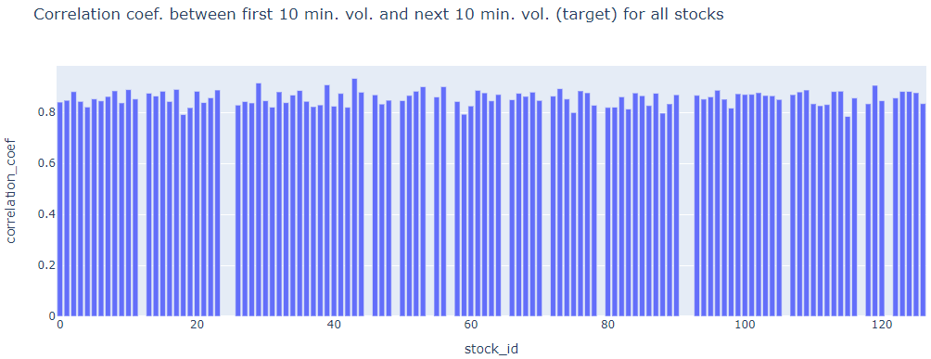

## past 10 min real vol is a good predictor of future 10 min real vol.

##### **Check correlation between**

##### **i) target (2nd 10 mins vol.) and trade execution stock price at the available times.**

Aggregate **trade execution price using the log returns and realised volatility formulas for each time id. Plot scatterplot this against the corresponding target for all time id.**

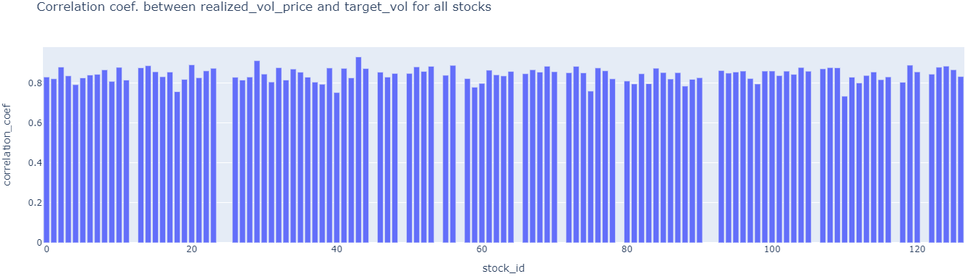

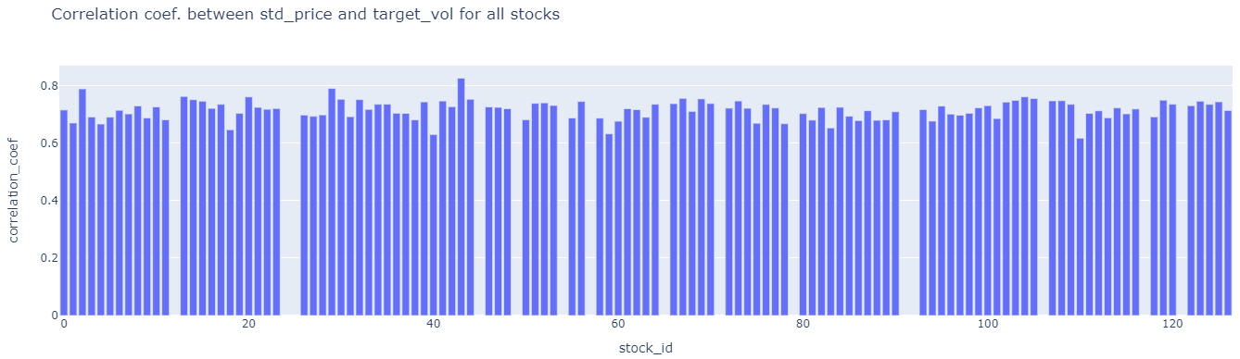

## 2) Bid Price VS Ask Price (For Stock 0 at time id 5):

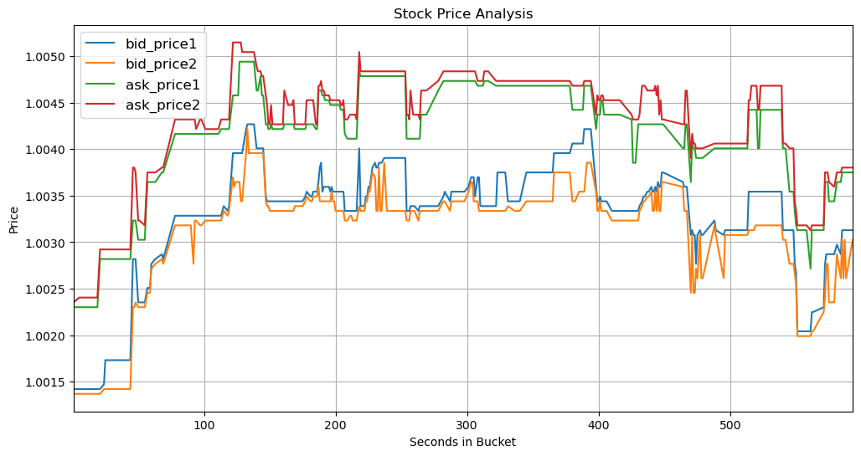

## 3) Stock Price VS WAP (For Stock 0 at time id 5):

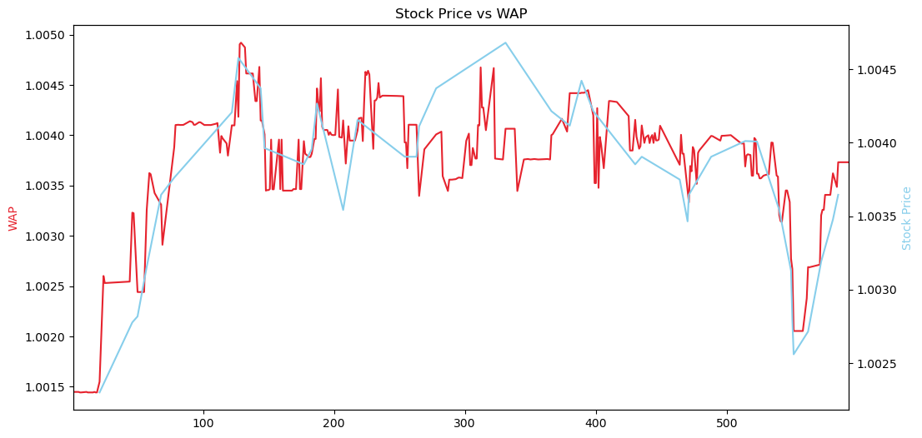

* Bid price and ask price form the lower and upper limit for WAP. WAP is correlated with the actual trade execution price (stock price) as shown above. Could we say that high volatilities in calculated WAP could indicate a high volatility in stock price?

## 4) Difference between Stock Price change and WAP for stock id 0 for aggregated all time id (Please verify this):

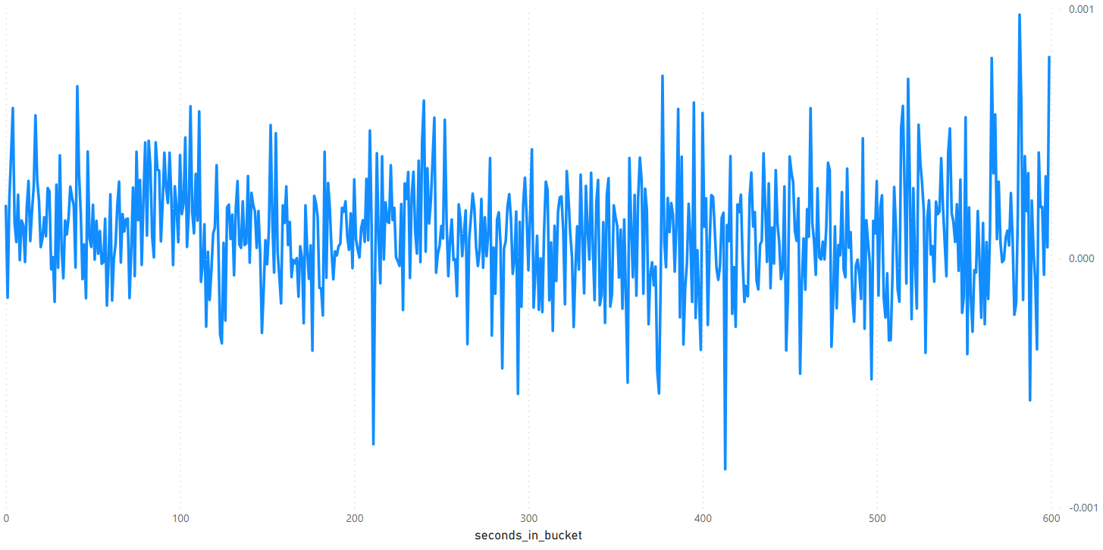

This represents the mean difference between the aggregated average of WAP across all time IDs and the price for stock ID 0. As we, can observe there is not much difference between both trends so we can safely say that the **correlation between WAP and Stock price (from trade data) is High.**

## 5) Correlation Heat Map (For Stock 0 at time id 5):

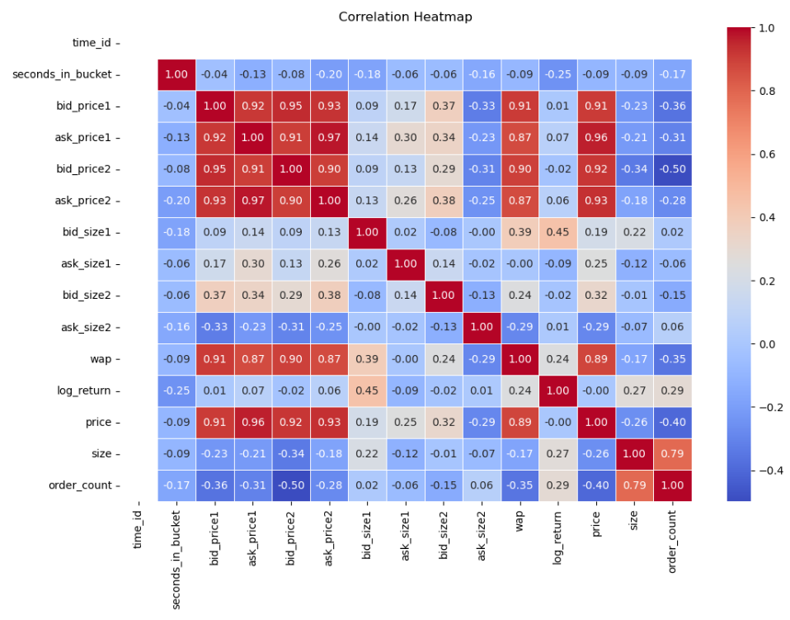

The correlation heatmap presented above reveals that our stock demonstrates a robust positive correlation with [bid_price1, ask_price1, bid_price2, ask_price2, wap], with an approximate 90% correlation coefficient. Conversely, there is a notable negative correlation of around 40% with the [order_count] variable.

## **6) Target realized volatility clustering analysis**

**Analysis file :** target_eda_across_stocks.ipynb

**Objective:** Group stocks that are similar to each other. The stocks that are similar can help to predict each other when used as covariates.

**Clustering based on :**

1. Target realized volatility Summary statistical features (i.e. Distributions) : [mean_vol,std_vol,min_vol,p25_vol,median_vol,p75_vol,max_vol]
2. Temporal target realized volatility correlation : pearson correlation between stocks for all time_ids.

**a) Clustering on Summary statistical features**

1. Perform feature orthogonalization by removing correlated features 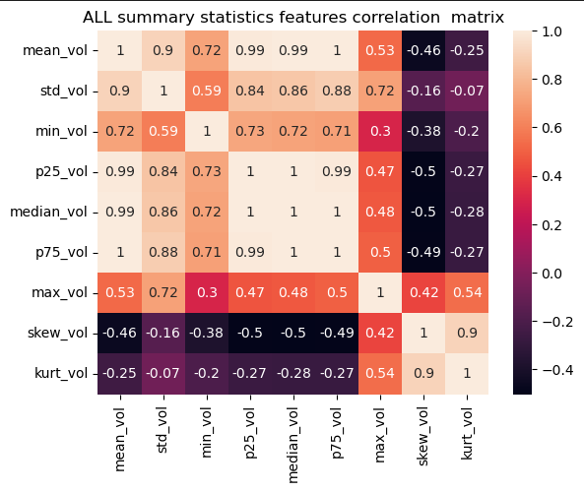

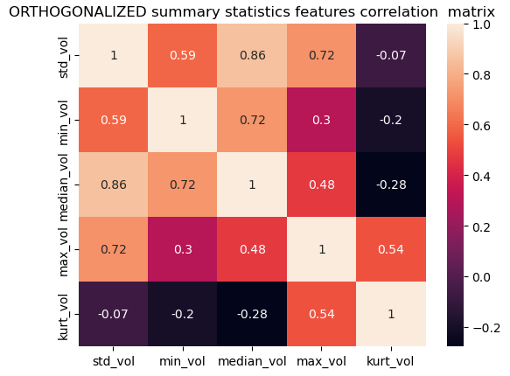

For large matrices PCA can also be used for feature orthogonolizaiton at the cost of losing intrepretatvility of principal components

1. Perform Dimensionality reduction to visualise how data is distributed in order to choose the appropriate clustering algorithm

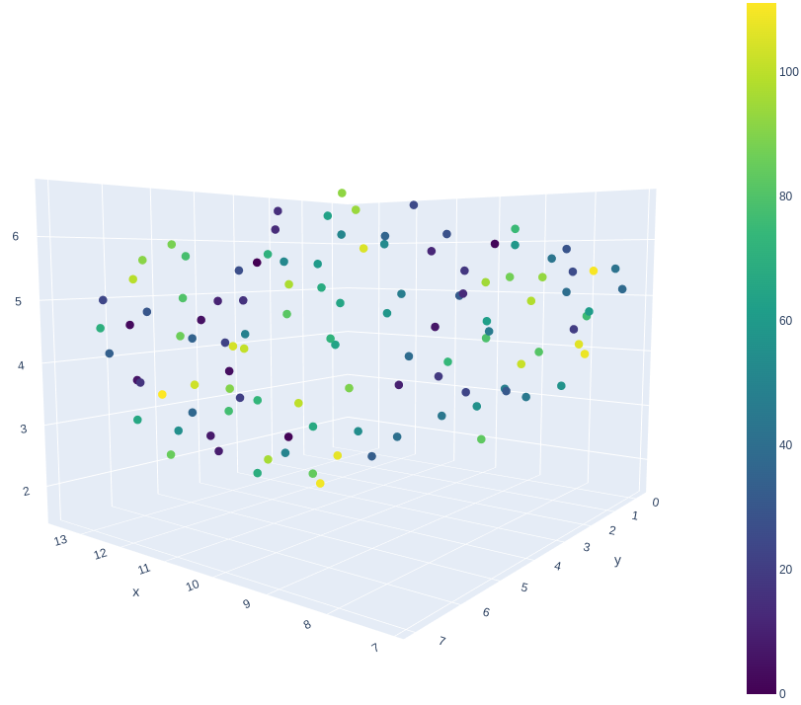

Which clustering algo. is better? K-means or Agglo. Hier. clustering?

Ans: Ultimately, silhouette scores decide but we can look at the data distribution as well and make an educated guess. Smaller dataset (that have non-spherical data distributions) Hier. clustering is better than k-means. k-means is faster on larger datasets. K-means if number of clusters is known. K-means works better if clusters are well linearly separated.

1. Perform clustering using various clustering algorithms and hyperparameters and check which one maximises the silhouette average score.

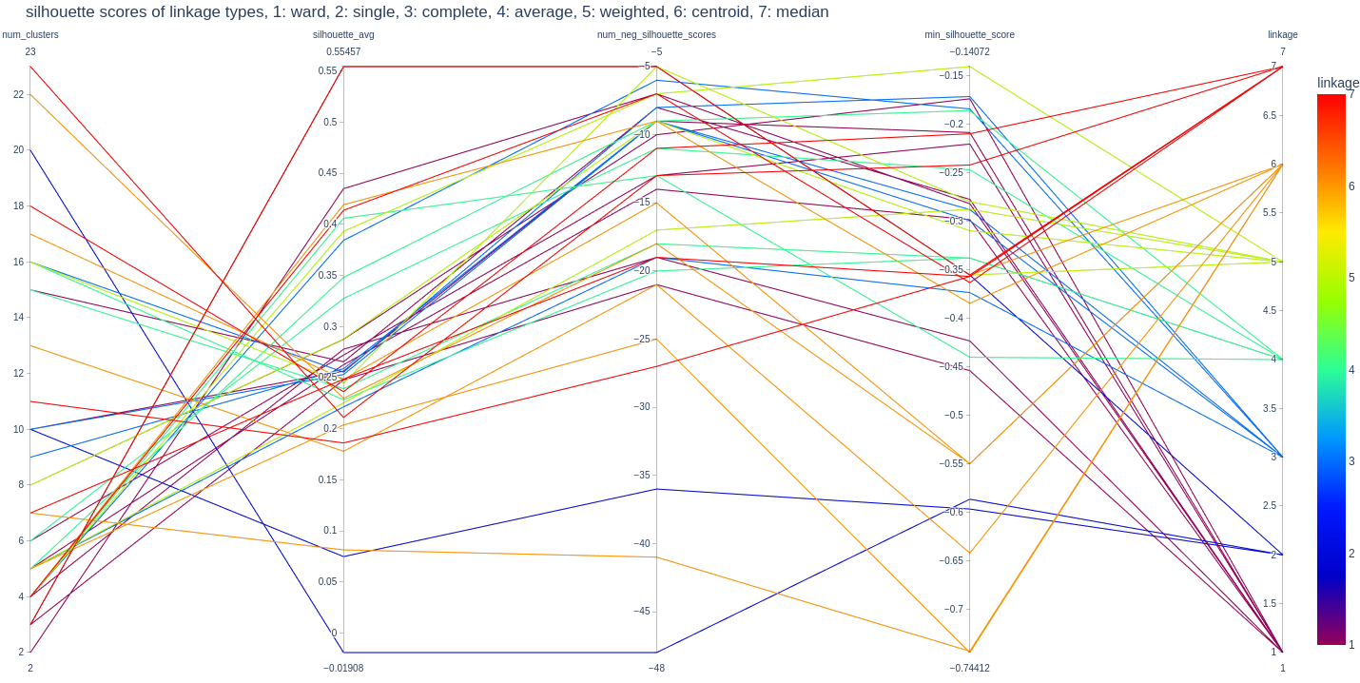

Select based on high average sil. Score and fewer number of negative sil. Score data points, select smaller minimum silhouette score.

Those stocks that have negative silhouette scores are like outliers and they can each be in their own cluster.

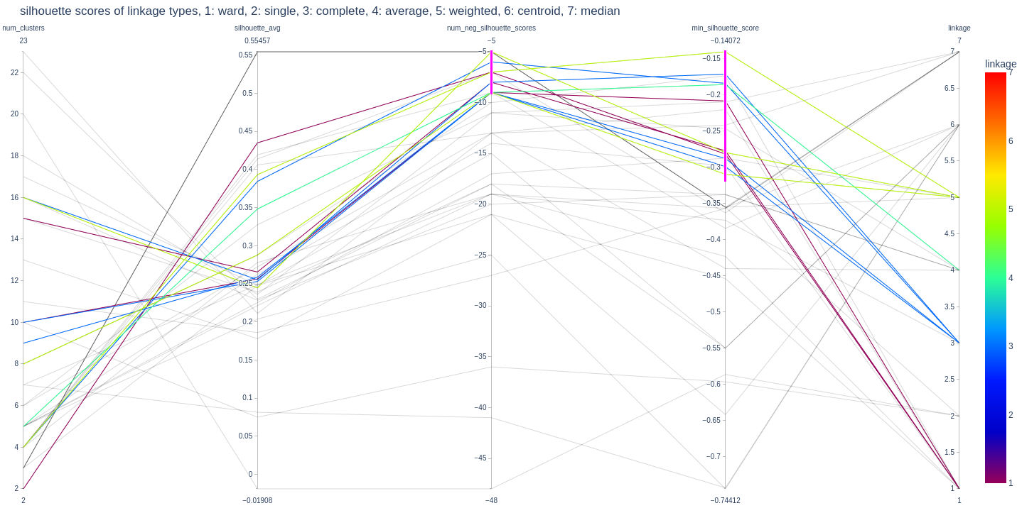

Chosen number of clusters: 2,4,5,8,9,10,15,16

All distances are euclidean.

Cluster parameters:

Num_clusters = 2, linkage = ward, threshold =2.5

Num_clusters = 15, linkage = ward,threshold = 0.5

Num_clusters = 10, linkage = ward,threshold = 0.7

Num_clusters = 15, linkage = ward,threshold = 0.5

Num_clusters = 4, linkage = complete,threshold = 1

Num_clusters = 9, linkage = complete,threshold = 0.6

Num_clusters = 10, linkage = complete,threshold = 0.5

Num_clusters = 16, linkage = complete,threshold = 0.4

Num_clusters = 30, linkage = complete,threshold = 0.25

Num_clusters = 5, linkage = average,threshold = 0.5

Num_clusters = 20, linkage = average,threshold = 0.25

Num_clusters = 3, linkage =weighted,threshold = 0.7

Num_clusters = 4, linkage =weighted,threshold = 0.6

Num_clusters = 8, linkage =weighted,threshold = 0.4

Num_clusters = 16, linkage =weighted,threshold = 0.3

Num_clusters = 3, linkage =centroid,threshold = 0.7

Num_clusters = 4, linkage =centroid,threshold = 0.6

Num_clusters = 3, linkage =median,threshold = 0.7

Num_clusters = 4, linkage = median,threshold = 0.6

Further shortlist from above.

Just choose any one color from each color. Others can be ignored.

We select:

Num_clusters = 4, linkage = complete,threshold = 1

Num_clusters = 10, linkage = complete,threshold = 0.5

Num_clusters = 16, linkage = complete,threshold = 0.4

Num_clusters = 30, linkage = complete,threshold = 0.25

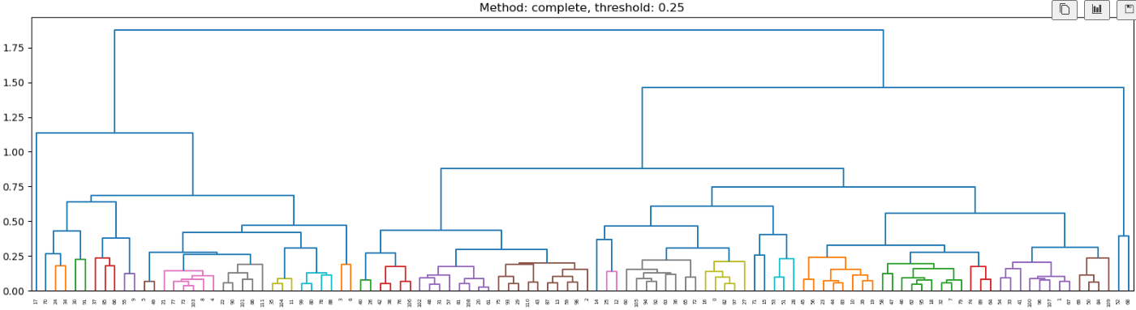

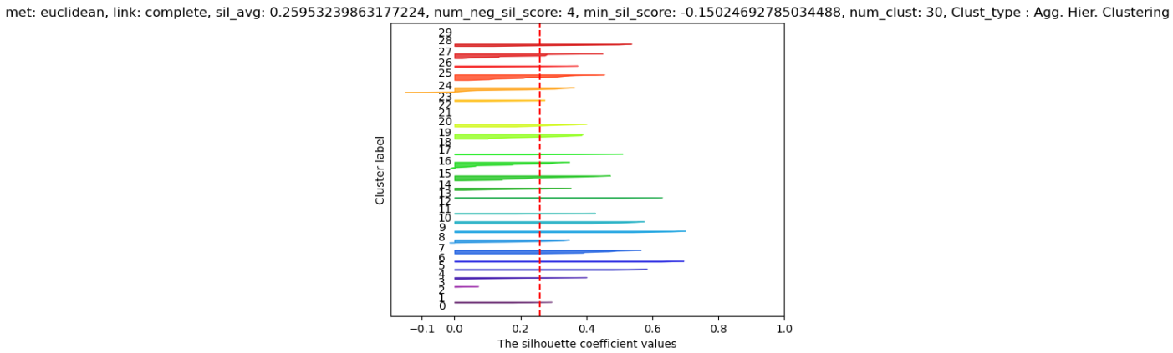

Note that the stock numbers shown in dendrogram is not actual stock number but just going from 0 to 111.

**use this to cluster first_10_min_vol_df feature using cluster_agg( ) function**

**b) Clustering on Temporal target realized volatility correlation**

**Reference:** <https://www.kaggle.com/code/sgalella/correlation-heatmaps-with-hierarchical-clustering>

1. Find ALL the unique time_ids from all stocks. Create a new target dataframe (train_common_time_ids_df ) with all these time_ids for all the stocks. Use forward and backward fills to populate missing values.
2. Find correlation matrix of this train_common_time_ids_df
3. Plot the (unclustered /ordered stocks) correlation matrix

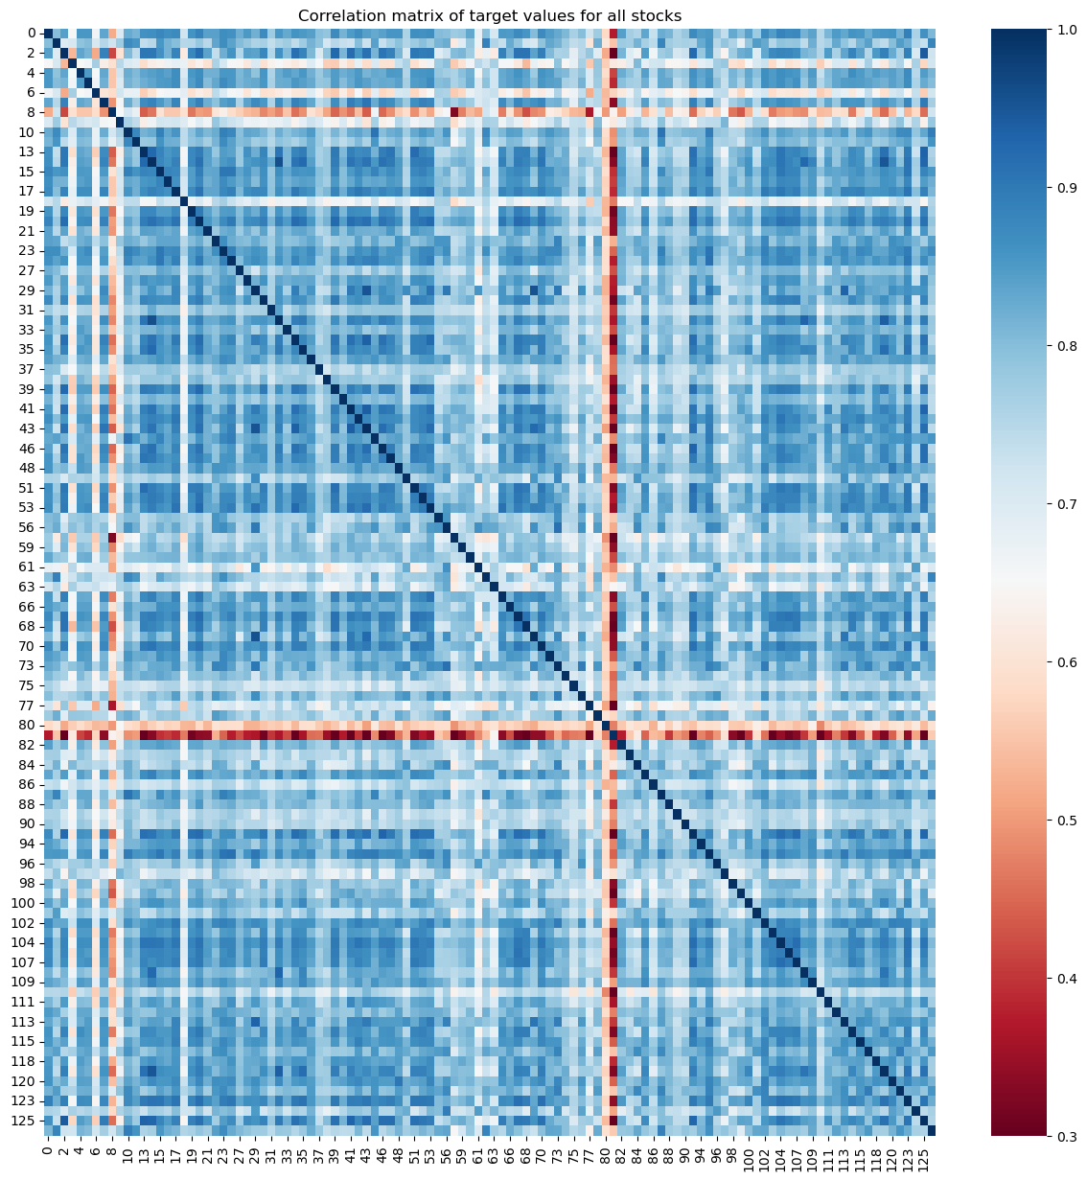

No negative or zero correlation. Correlation starts at 0.3.

1. Check that there is no NEGATIVELY correlated stock pairs.

If there are negatively correlated stock pairs they need to be SEPARATELY clustered from the positively correlated stock pairs.

In this dataset all are positively correlated. (usually the case if the time interval is long enough.)

1. For each stock sort the most correlated stocks. This can help to validate clusterings formed later on.
2. Perform agglomerative hierarchical clustering to cluster similar stocks based on pearson correlation. Stocks that realised volatility that move together are clustered together.

The linkage function takes the pairwise correlations between stocks. I.e. (N*(N-1))/2 entries in the upper triangular part of the correlation matrix.

The methods used like single/complete/ward etc. are different ways to combine the indiv. stocks and then clusters of stocks until there is only 1 cluster left. <https://www.youtube.com/watch?v=8QCBl-xdeZI>

<https://www.youtube.com/watch?v=vg1w5ZUF5lA>,

This is shown on dendrogram. The y-axis is the distance we provided (i.e. 1 - pearson_correlation ) for methods like single and complete BUT not for all methods e.g. average.

**Best methods: 1)** Ward, 2)Complete

Ward method is the best because it creates more compact clusters due to centroid formation and clusters combine based on new centroid formations. Other methods combining may note be good because they are combining based on edge point of the cluster alone whereas ward combines based on centroid which is better representative of the cluster than a single point i..e edge point.

WARD method: Try this first and see if prediction accuracy is good.

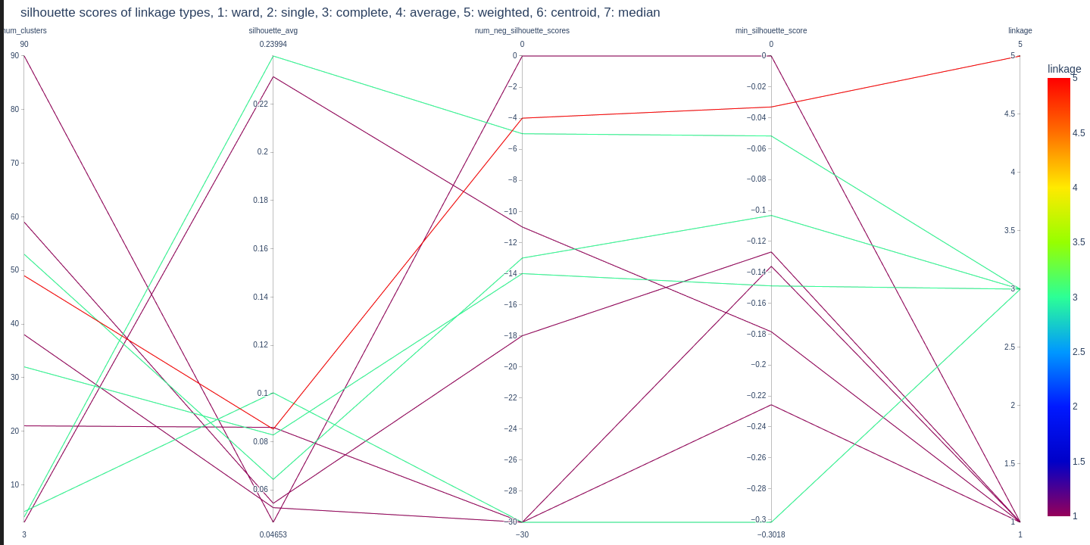

Cluster parameters:

Num_clusters = 4, linkage = complete, threshold = 0.45

Num_clusters = 32, linkage = complete, threshold = 0.2

Num_clusters =49, linkage = weighted, threshold = 0.15

Num_clusters =90, linkage = ward, threshold = 0.1

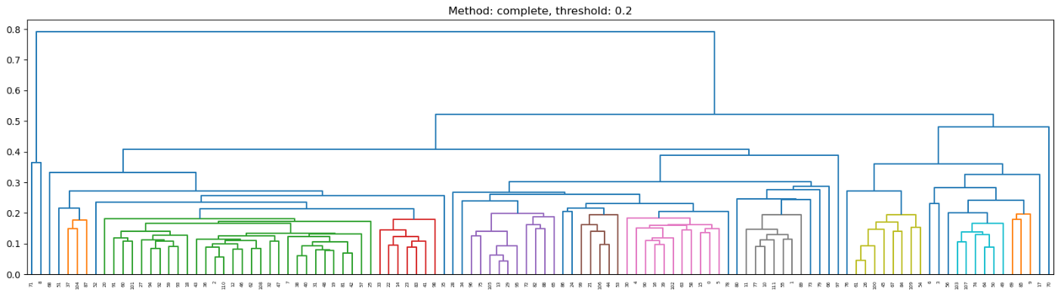

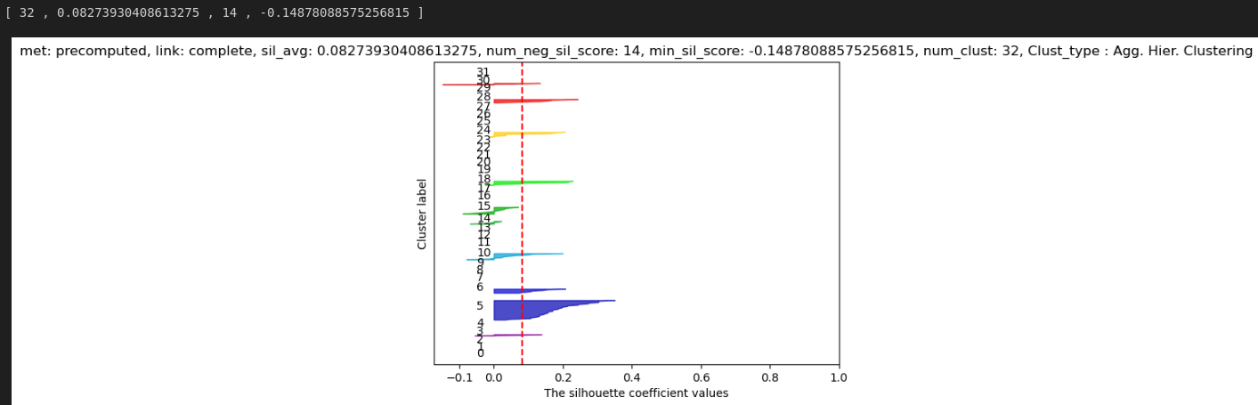

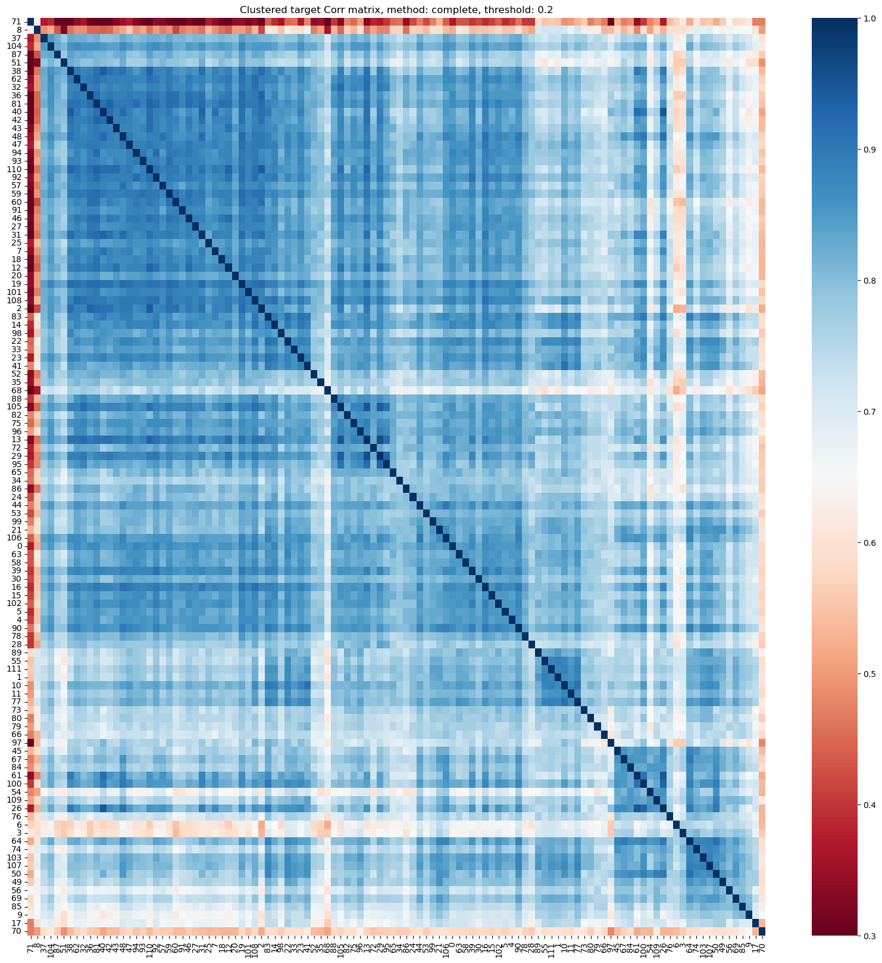

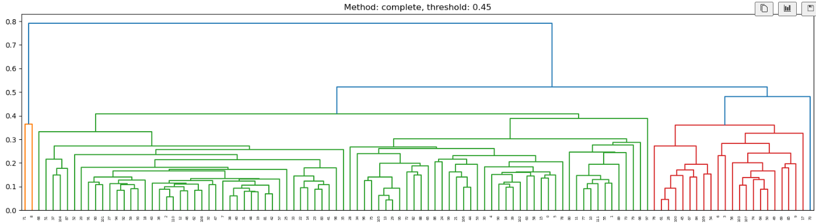

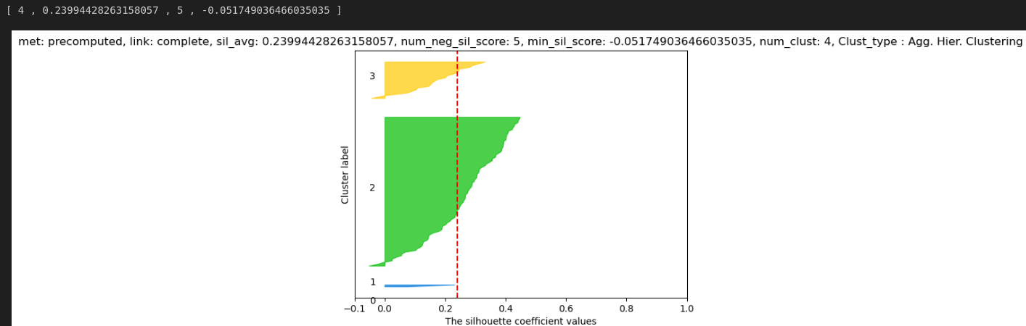

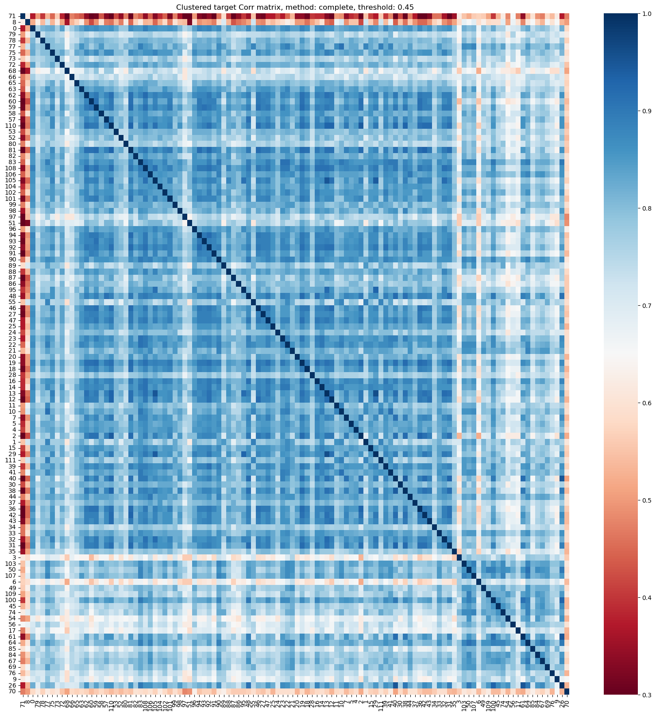

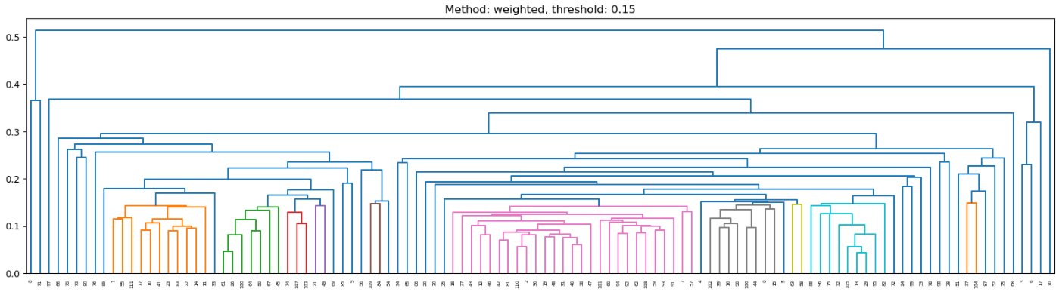

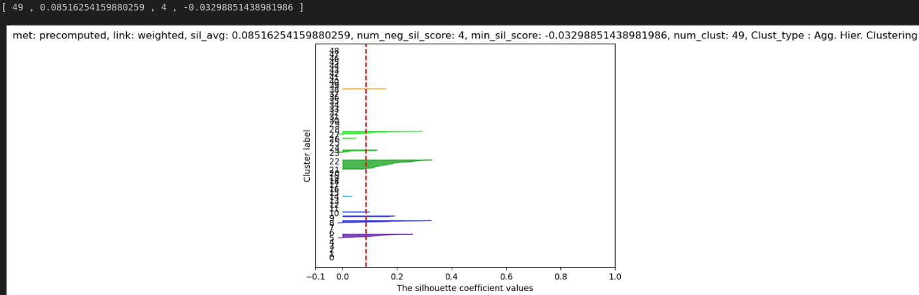

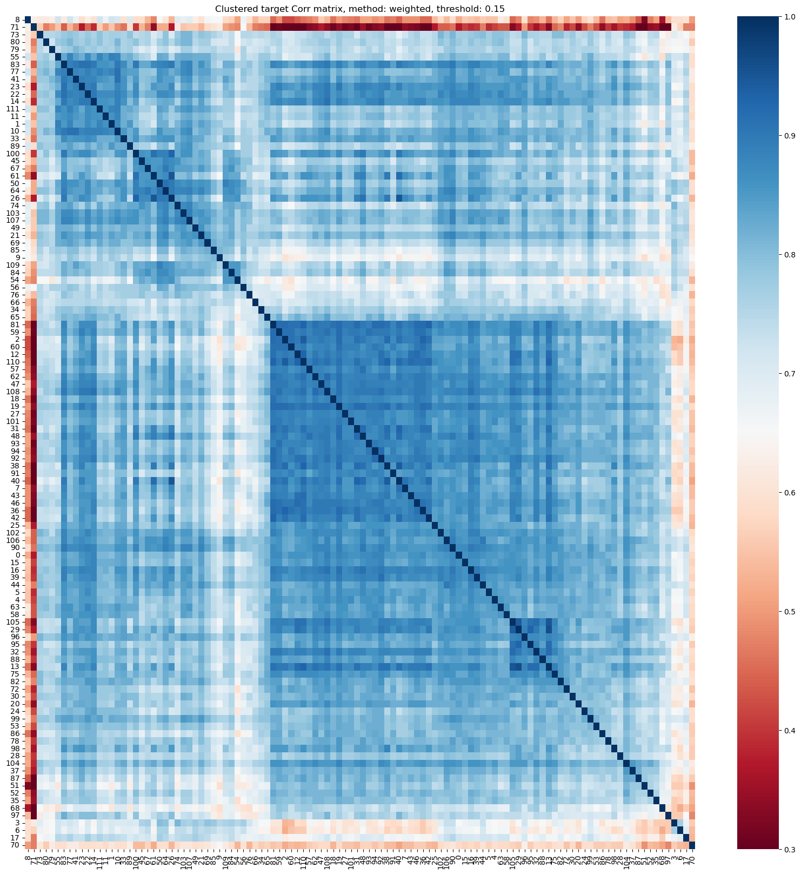

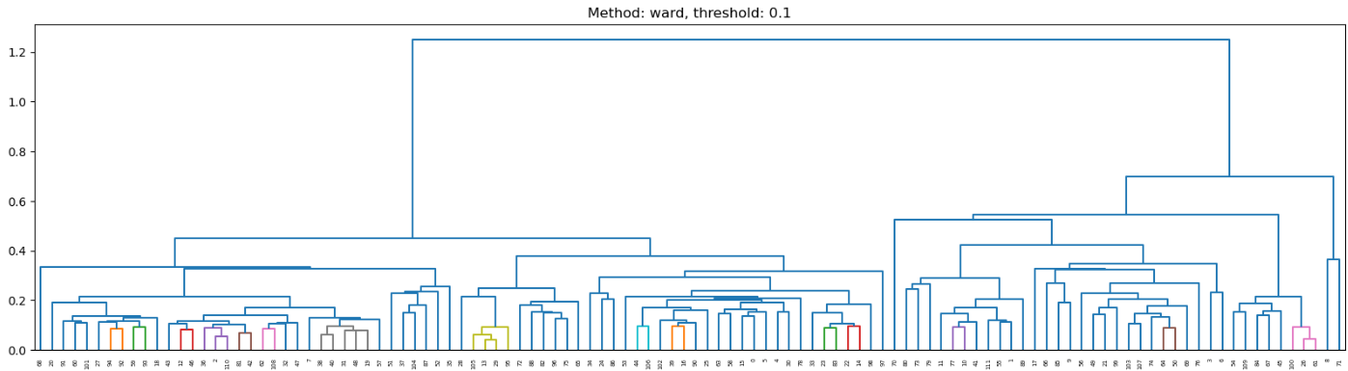

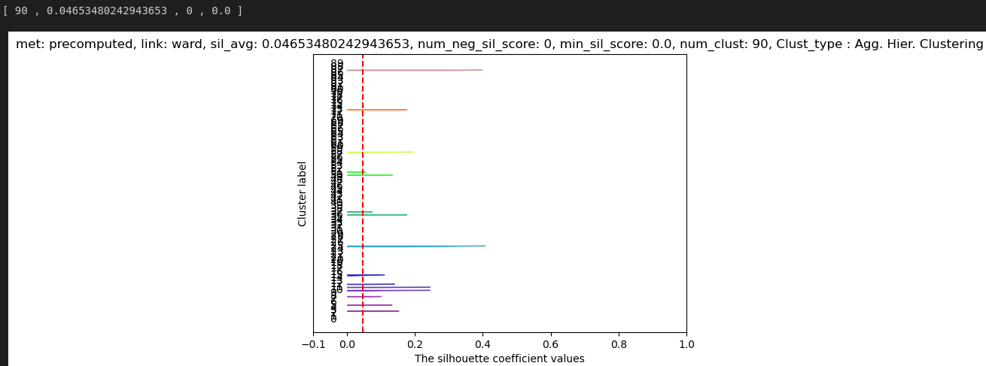

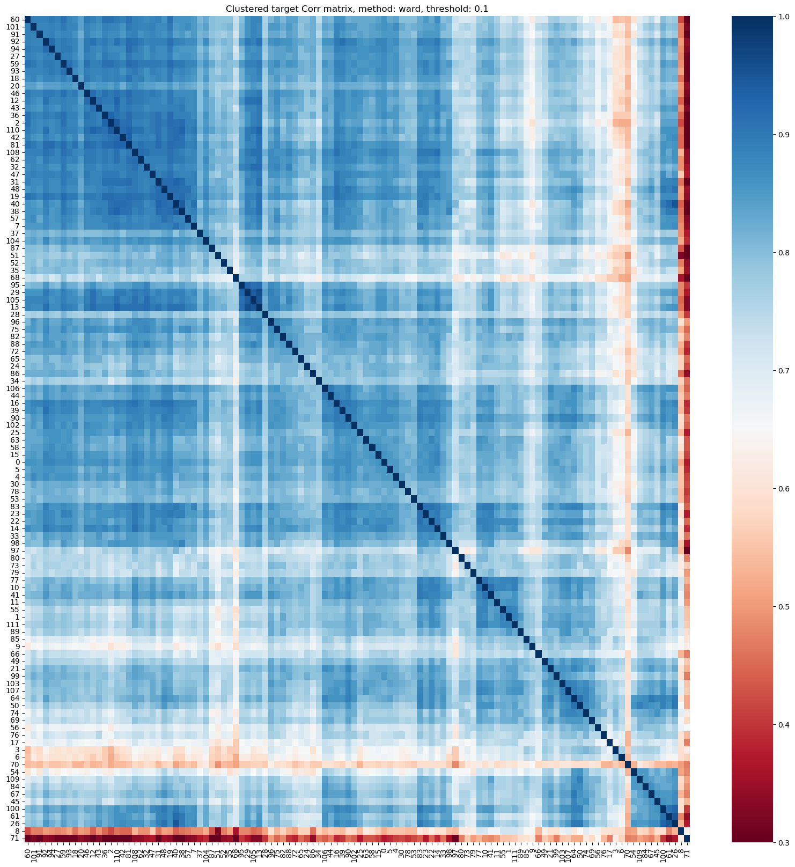

Look at the diagonal line. The square shaped clusters along the diagonal represent the groups/clusters of correlated stocks.

SKew and kurtosis of prices and log transformed prices

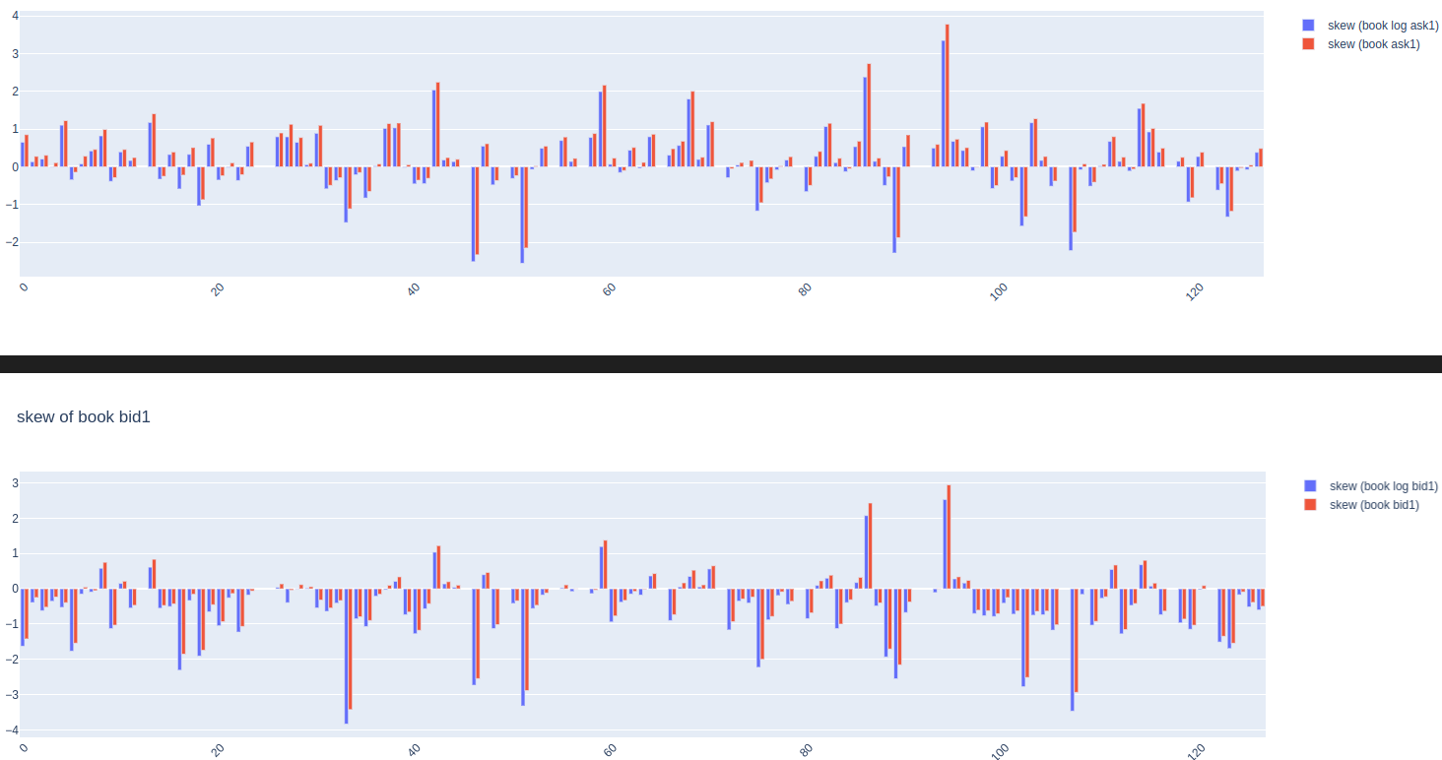

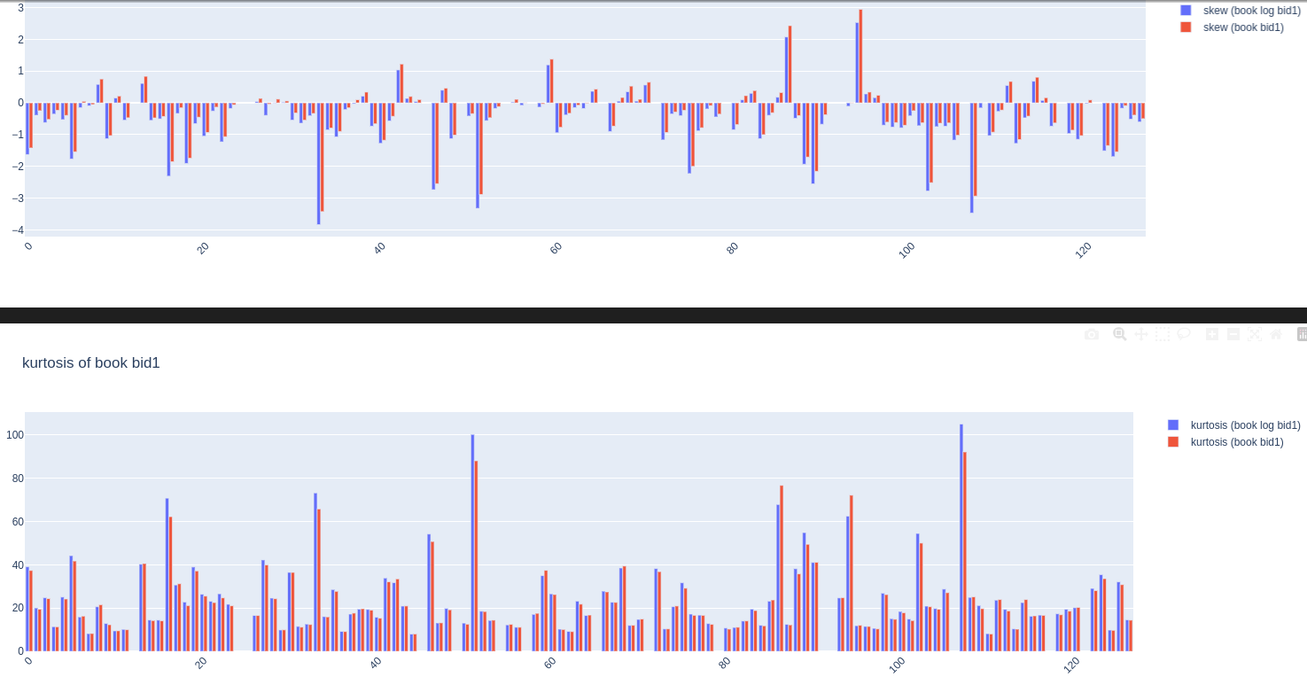

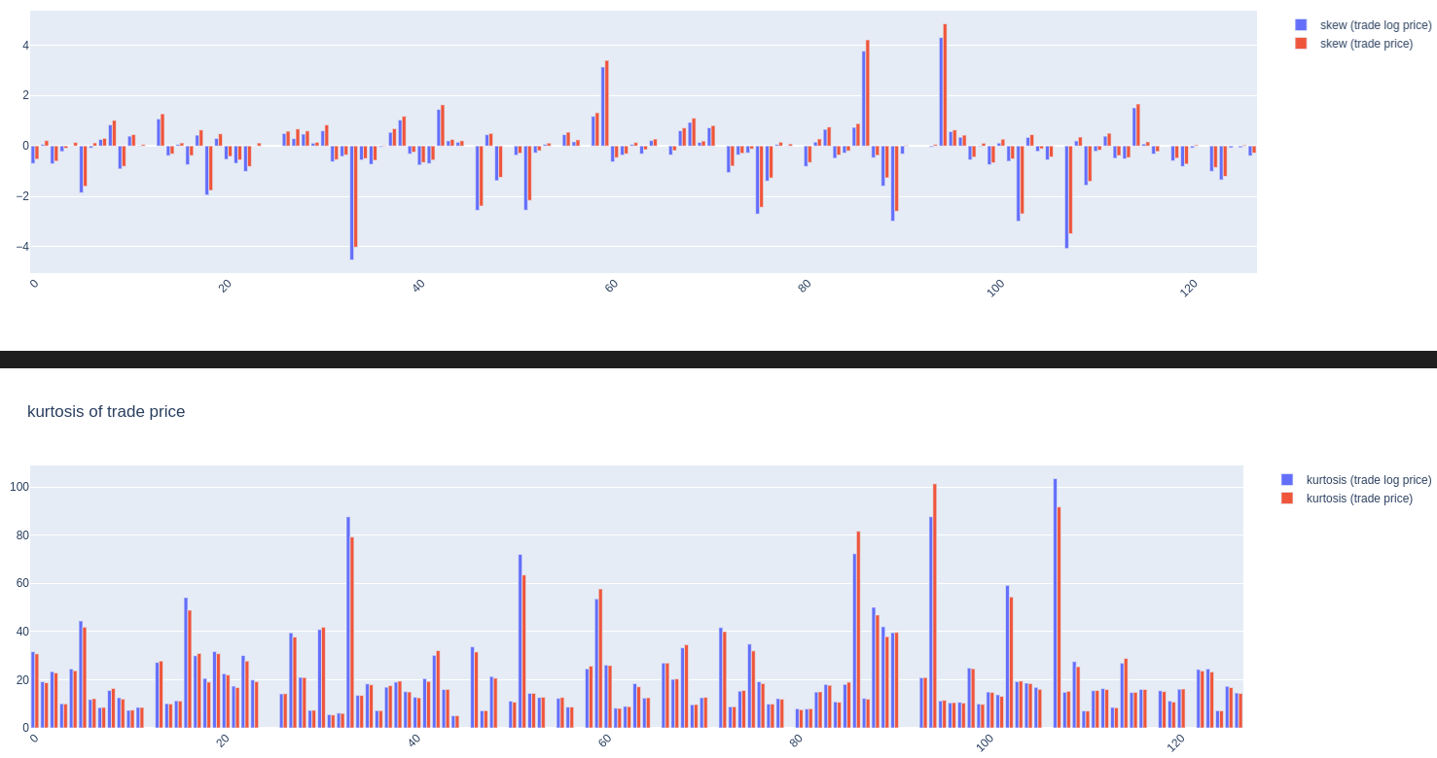

For all graphs, log transformation decreases positive skew and increases negative skew. THis can be observed above. For positive skew, log transformation decreases kurtosis (with one exception for stock 16). For negative skew, log transformation increases kurtosis.

Most stock’s Bid price is left skewed and ask price is right skewed.

Log helps to reduce right skewed stocks but also increase skew of left skewed stocks.

Negative skewed stocks fatness (kurtosis) decreased as points became shifted further to the left by log transformation and positive skewed stocks fatness (kurtosis) increased. This not entirely true. For smaller positive skewed stocks, kurtosis does decrease with log transformation. Check liquidity_features_inux.ipynb for bigger figure.

**LIquidity Feature Descriptions**

***Background information***

* Number of buckets = 30
* Bucket width = 20 seconds
* Spread = log ask price1 - log bid price1
* Spread2 = log ask price2 - log bid price2
* Book size = book volume1 + book volume 2
* Book Volume = ask size * ask price + bid size* bid price
* Trade volume = trade size * trade price
* Suffix with _**buks** stands for simply summed over within the bucket.
* Suffix with _**wavg** stands for time weighted average within the bucket. Weighted by amount of time spent till the next time point. Instead of simply summing like above, we give more weight to more persistent points.

Time weighted = x1*(t2 - t1) + x2(t3 - t2) + … / ( (t2 - t1) + (t3 - t2) )

* **wap1_log_price**: is wap1 computed using the LOG of bid and ask price in the WAP formula.
* **wap2_log_price_ret_changes_n_wap1_log_price_ret_constant**: # this indicates the changes in level 2 wap when level 1 wap does NOT change # This happens when all orders in level 1 are filled and new orders are placed in level 2 # indication of liquidity as prices in level 2 are moving towards level 1 # Aggressive Market Orders, Imbalance in Market Depth, Execution of Large Orders, Liquidity Changes:
* Suffix with _**vol** stands for volatility: WHich is some form of aggregation (e.g. sum of absolutes or square root of sum of squares) of returns. In volatility calculations we assume that the quantity has zero mean because taking log of the quantity centers it around the mean usually. So simply squaring and then summing results in the variance formula. Although it does not divide by number of terms.
* **_abs_vol_** stands for simple sum of returns within a bucket.
* **_sqr_vol_** stands for square root sum of squared returns within a bucket.
* NOte: The definition of log returns is different here compared to the competition log return.

Competition formula:

log( as1*bp1 + bs1*ap1 /as1+bs1)_t2 - log( as1*bp1 + bs1*ap1 /as1+bs1)_t1 = log(s_t2/s_t1) = return

Customized formula:

Wap1_log_price_ret = ( ( as1*log(bp1) + bs1*log(ap1) ) /as1+bs1 )_t2 - ( ( as1*log(bp1) + bs1*log(ap1) ) /as1+bs1 )_t1

* Find (a few different) equilibrium prices between bid and ask price where trades are likely to happen. The different prices are the result of levels 0,1, and 2. # Find equilibrium price at which trades are likely to happen # This price minimizes the missing total volume from buy and sell side.

book_data[**'wap_eqi_price0'**] = find_equilibrium_price( book_data, lvl=0)

book_data[**'wap_eqi_price1'**] = find_equilibrium_price( book_data, lvl=1)

book_data[**'wap_eqi_price2'**] = find_equilibrium_price( book_data, lvl=2)

* **Wap_eqi_price0_ret**: returns (first difference) of **'wap_eqi_price0'**
* **Wap1_log_price_ret_pos_log_liq_ret**: the **wap1_log_price_ret** when **log_liquidity1_ret** is positive
* **Wap1_log_price_ret_neg_log_liq_ret** : the **wap1_log_price_ret** when **log_liquidity1_ret** is negative
* **Log_liquidity1_ret**: the returns (first difference ) **log_liquidity1**
* **Log_liquidity1** : log of **liquidity1**
* **liquidity1**: It is proportional to volume = size*price (not log price). And inversely proportional to distance from equilibrium price. HIgher volume = higher liquidity. Farther from equilibrium price lower the liquidity.

book_data[**'liquidity1'**] = (

book_data['bid_volume1']/( 1000*(book_data['wap_eqi_price1'] - book_data['log_bid_price1']) )

+ book_data['bid_volume2']/( 1000*(book_data['wap_eqi_price1'] - book_data['log_bid_price2']) )

- book_data['ask_volume1']/( 1000*(book_data['wap_eqi_price1'] - book_data['log_ask_price1']) )

- book_data['ask_volume2']/( 1000*(book_data['wap_eqi_price1'] - book_data['log_ask_price2']) )

)

* **Wap1_log_price_amp_max_wavg** :
* **Wap1_log_price_amp_min_wavg :**

# filter out the extremely high and low prices of wap1_log_price by multiplying with a large number like 4000 and amplifying with postiive and negative exponential of wap1_log_price. Taking log and -log undoes the positive and negative exponentiation.

# apply time weighted average to the amplified wap1_log_price

# what may be the physical meaning?

book_n_trade_data['wap1_log_price_amp_max_wavg'] = np.log( bucketized_time_weighted_avg_data(np.array(book_data['seconds_in_bucket']),

np.array(book_data['time_id']),

np.exp( 4000*np.array(book_data['wap1_log_price'])),

np.ones((book_data.shape[0])),

20, 30, ids.shape[0]) )/4000

book_n_trade_data['wap1_log_price_amp_min_wavg'] = -np.log( bucketized_time_weighted_avg_data(np.array(book_data['seconds_in_bucket']),

np.array(book_data['time_id']),

np.exp(-4000*np.array(book_data['wap1_log_price'])),

np.ones((book_data.shape[0])),

20, 30, ids.shape[0]) )/4000

* **Ask_liq1_diff**: # difference between ask's level 1 and level 2 liquidity

book_data['ask_liq1_diff'] = (

book_data['ask_volume1']/( 1000*(book_data['wap_eqi_price1'] - book_data['log_ask_price1']) )**1

- book_data['ask_volume2']/( 1000*(book_data['wap_eqi_price1'] - book_data['log_ask_price2']) )**1

)

* **Bid_liq1_diff**: # difference between bid's level 1 and level 2 liquidity

book_data['bid_liq1_diff'] = (

book_data['bid_volume1']/( 1000*(book_data['wap_eqi_price1'] - book_data['log_bid_price1']) )**1

- book_data['bid_volume2']/( 1000*(book_data['wap_eqi_price1'] - book_data['log_bid_price2']) )**1

)

***Total 46 liquidity*** ***features***

1. **'wap1_log_price_ret_buks'** : bucketized wap1_log_price_ret, where wap1_log_price_ret is returns (first difference ) of wap1 computed using the LOG of bid and ask price in the WAP formula. Tells whether there was a net increase/decrease in WAP within a bucket. # Amount of wap1 price movements in a time bucket of 30 seconds,
2. **'Wap1_log_price_ret_abs_vol_buks'**: # Amount of sum of absolute wap1 price movements in a time bucket of 30 seconds, i.e. absolute wap1 returns volatility in bucket. Measure amount of price activity regardless of prices going up or down. It’s like volatility.
3. **'Wap2_log_price_ret_abs_vol_buks'**: same as above for using level 2 for wap2.
4. **'Wap1_log_price_ret_sqr_vol_buks'**: same as above but it’s squared, gives larger weight to larger price changes. Measure amount of (large) price activity regardless of prices going up or down.
5. **'Wap2_log_price_ret_sqr_vol_buks'**: same as above for using level 2 for wap2.
6. **'Wap1_log_price_ret_vol_buks'**: volatility of returns within a bucket. Square root of Sum of squared returns.
7. **'wap2_log_price_ret_vol_buks'**, same as above using level 2 price, wap2.
8. **‘wap2_logprice_ret_changes_n_wap1_logprice_ret_constant_sqr_vol_buks'**: see above. bucketized Volatility of wap2 returns when wap1 returns are 0.
9. **'Wap_eqi_price0_ret_abs_vol_buks'**: # equilibrium price returns absolute volatility in bucket
10. **'Wap_eqi_price0_ret_sqr_vol_buks'**: same as above but volatility calculated using square root of squared returns
11. **'Wap_eqi_price1_ret_sqr_vol_buks'**: same as above but using eqi_price_1
12. **'Wap1_log_price_ret_pos_log_liq_ret_sqr_vol_buks'**: the **wap1_log_price_ret** when **log_liquidity_ret** is positive i.e. increasing liquidity.
13. **'Wap1_log_price_ret_neg_log_liq_ret_sqr_vol_buks'**: the same as above but when **log_liquidity_ret** is negative i.e. decreasing liquidity.
14. **‘log_liq2_ret_*_wap_eqi_price1_ret_vol_buks'**: product of **‘log_liq2_ret_** and **_wap_eqi_price1_ret_vol_buks'** squared. It measures large movements in log_liquidity and wap_eqi_price1 regardless of the directions.
15. **'exp_log_liq1_ret_*_wap_eqi_price1_ret_vol_buks**': # wap equilibrium price 1 returns volatitlity in bucket amplified (> 1) by positive/increasing liquidity returns (through exponent) # and diminished ( < 1) by negative/decreasing liquidity returns (through exponent). It checks whether wap_eqi_price1 is high or low during positive log liq1 ret. It ignores when it is negative. The final term is squared.
16. **'exp_log_liq1_ret_*_wap_eqi_price1_ret_vol_buks_2**': Just a copy of the above.
17. **'Wap1_log_price_ret_per_spread_sqr_vol_buks'**: # variance/ squared volatitliy of wap1 price returns per unit of spread # large value indicates volatilty. When the numerator is big then liquidity is less. When denominator is big then liquidity is also less. A large number indicates high volatility.
18. **'Wap1_log_price_ret_per_liq2_vol_buks'**: # variance/ squared volatitliy of wap1 price returns per unit of liquidity # small value indicates less volatilty?
19. **'Log_liquidity1_ret_sqr_vol_buks'**: # measure of variance/ squared volatility of log liquidity1 returns. Measure of variance in log liquidity in each bucket. If liquidity fluctuates then volatility is also coming.
20. **'Log_spread_ret_sqr_vol_buks'**: # measure of variance/ squared volatility of log spread returns in each bucket.
21. 'Book_delta_count_buks': # counting number of data points available in each time bucket.
22. **’'Wap1_log_price_wavg'**: # time weighted average of wap1_log_price in each time bucket.
23. **'Wap2_log_price_wavg'**: same as above for level 2
24. **'Wap_eqi_price0_wavg'**: # time weighted average of wap_eqi_price0 equilibrium price in each time bucket
25. **'Wap_eqi_price1_wavg'**: same as above for price1
26. **’Wavg_wap1_log_price_amp_diff'**: # amplification of the difference between wap1_log_price_amp_max_wavg and wap1_log_price_amp_min_wavg. It is like a measure of spread between the max and min wap1 prices in a time id.
27. **'Wavg_wap_eqi_price0_amp_diff'**: same as above for price 0
28. **'Liquidity1_wavg'**: time weighted average of liq1
29. **'Liquidity2_wavg'**: same as above for liq2.
30. **'Root_liquidity2_wavg'**: time weighted average of square root of liq2
31. **'Spread_wavg'**: time weighted average of spread
32. **'Inv_spread_wavg'**: time weighted average of inverse spread
33. **'Log_spread_wavg'**: time weighted average of log spread
34. **'Log_spread2_wavg'**: same as above but using log bid price 2 and log ask price2
35. **'Book_size1_wavg'**: # time weighted average of book size1 in each time bucket
36. **'Book_size_wavg'**: # time weighted average of book size1 in each time bucket
37. **'Trade_volume_buks'**: bucketized trade volume, Trade volume = trade size * trade price
38. **'Sqrt_trade_volume_buks'**: same as above but bucketize the square root of trade volume. Effect of trade volume on market (future price) impact.
39. **'Cube_root_trade_volume_buks'**, same as above
40. **'trade_volume_p2/3_buks'**: same as above
41. **'Quart_root_trade_volume_buks'**: same as above
42. **'Trade_count_buks'**: # count the number of trades in each time bucket
43. **'Trade_volume_per_liquidity1_wavg_buks'**: trade_volume_buks/ liquidity1_wavg
44. **'Trade_volume_per_liquidity2_wavg_buks'**: trade_volume_buks/ liquidity2_wavg
45. **'Ask_liq1_diff_wavg'**: # time weighted average of difference betweeen ask's level 1 and level 2 liquidity. ask_liq1_diff - bid_liq1_diff
46. **'Bid_liq1_diff_wavg'**: # time weighted average of difference betweeen bid's level 1 and level 2 liquidity

Transformation of Volume maybe due to square root law of the market impact??

<https://www.reddit.com/r/algotrading/comments/kuupuz/square_root_law_of_the_market_impact_simplest/>

**CLUSTERING ANALYSIS**

Identify features that have similarity across stocks.

Sqrt_trade_volume_buks

Trade_volume_buks

Wap1_log_price_ret_vol_buks

wap1_log_price_ret_buks

Log_spread_wavg

Liquidity1_wavg

liquidity2_wavg

* # average out along the buckets axis
* Take Log of these features.
* log_trade_volume_per_liquidity1 = np.log(np.mean( sqrt_trade_volume_buks, 2)/np.mean( liquidity1_wavg, 2))

**Perform_clustering( )** function

CReate correlation coefficient matrix

* # feature shape of (time_id=3830,stock_id= 112)
* Input is a particular feature for all stocks
* # replace nan with mean
* # feature standardization along time_id axis
* # correlation coefficient between stocks, C.shape = 112x112
* # fisher z transformation, it normalizes the distirution of C, make it more symmetric and stabilize the variance as correlation is bounded by [-1,1]
* # After arctanh the values are unbounded
* # set diagonal self-correlation elements to zero
* # mean centering
* # mean of correlation of a stock to every other stock. e.g. stock 1 to stock 2,3,4,5,6,etc..
* # e.g. For CORR_1,2 subtract product of mean of correlation of a stock 1 to every other stock and mean of correlation of stock 2 to every other stock
* # set diagonal self-correlation elements to mean of all correlations
* # perform pca over time_id axis

Perform PCA over the features to cluster on the PCs

* # perform pca over time_id axis
* # 112 components, each component has 112 loadings (represnting stock ids)
* # singular values (eigenvalues) represent the variance contribution of each component or the true rank of the matrix
* # when singular values are close to zero, the corresponding components can be ignored so we multiply the components with singular values
* # Transpose, i.e. dimension of scaled_pcs is now stock ids x principal components.
* # each row represents a stock and its entry is a contribution from each of the principal components
* # Visualize the first 3 principal components of the scaled_pcs to select the clustering algorithm
* # compare the visualization of first 3 principal components of the scaled_pcs with the dim. reduced UMAP of scaled_pcs matrix
* # 1) visualize the scaled_pcs vector distribution in low dim. space in order to choose approapriate clustering algorithm
* # lower dim. distribution of summary stats. vector is representative of the original high dim. distribution
* ### static UMAP
* # do not normalize the PCs because each component explains different amount of variance.
* # IF we normalize and bring it to same scale, we will lose the variance information between components. # replace o_tree clusters with agglomerative hierarchical clustering
* # threshold_depth sets the number of clusters
* # find mean principal component for each cluster
* # check if GMM is suitable for clustering
* # perform GMM clsutering
* # select all pairwise correlations between all the stocks in a cluster
* # mean of z transformed pairwise correlation coefficients of all stocks belonging to a cluster,
* # compute clustering score for a particular feature with a fixed number of clusters. Changing cluster number / threshold depth can improve or decrease clustering score.
* # select all pairwise correlations between all the stocks in a cluster
* # mean of z transformed pairwise correlation coefficients of all stocks belonging to a cluster
* # score is clustering density, sum of mean correlation per cluster over all clusters, penalized by number of clusters. A large negative or positive value is preferred. Closer to zero is bad.
* # this can also help to find the correct number of clusters
* # group stocks by cluster from smallest to largest labels
* # display the correlation values of stocks in each cluster next to each other

Find_high_correlation_stocks( ) function

* # select the percentile in order to set the threshold for correlation coefficient
* # use percentile when its difficult to set the threshold at a particular value
* Find a global measure that finds a stock or a few stocks that has MOST (not necessarily high) correlation with ALL the other stocks
* # correlation coefficient between stocks, C.shape = 112x112
* # select the median correlation coefficient of each stock
* # mask of stocks with median correlation coefficient above cutoff percentile
* # select the indexes of stocks in the feature matrix > cutoff percentile (NOT stock ids)

**FEATURE ENGINEERING**

Using the **46 liquidity** **features** above, more features are created through taking ratios of quantity between earlier and later buckets, creating volatility per unit of wap1_logprice_ret volatility, as ….. including clustering results.

Total 153 liquidity features stored in final_features dictionary

All features below are averaged along the buckets axis before computing the feature.

1. **‘‘Wap1_log_price_ret_vol’:**  # average out along the buckets axis
2. ‘**log_liq2_ret_*_wap_eqi_price1_ret_vol**’: large movements in log_liquidity and wap_eqi_price1 regardless of the directions per unit of wap1_log_price_ret_vol. Taking log of this gives positive and negative numbers if quantity is >1 or < 1.
3. **‘exp_log_liq1_ret_*_wap_eqi_price1_ret_vol**’: measure of increasing liquidity and volatility in equilibrium price per unit of wap1_log_price_ret_vol. Taking log of this gives positive and negative numbers if quantity is >1 or < 1.
4. ‘**exp_log_liq1_ret_*_wap_eqi_price1_ret_vol_2**’: copy of above
5. **‘Wap1_log_price_ret_per_liq2_vol’**: # average out along the buckets axis
6. **‘Wap1_log_price_ret_per_spread_sqr_vol’**: # average out along the buckets axis
7. ‘**log_liq2_ret_*_wap_eqi_price1_ret_vol_15_ratio**’: # ratio of mean of last 15 buckets to mean of first 15 buckets within a time id. ratio > 1 means increasing trend. ratio < 1 means decreasing trend.
8. **‘Wap1_log_price_ret_per_liq2_vol_15_ratio’:** similar to above.
9. **‘Wap1_log_price_ret_per_spread_sqr_vol_15_ratio’**: # ratio of mean of last 15 buckets to mean of first 15 buckets within a time id. ratio > 1 means increasing trend. ratio < 1 means decreasing trend
10. ‘**exp_log_liq1_ret_*_wap_eqi_price1_ret_vol_15_ratio**’: similar to above
11. **‘exp_log_liq1_ret_**\***_wap_eqi_price1_ret_vol_2_15_ratio** ’: similar to above
12. **‘Wap2_logprice_ret_changes_n_wap1_logprice_ret_constant_sqr_vol_15_ratio’:** similar to above
13. **‘Wap2_logprice_ret_changes_n_wap1_logprice_ret_constant_sqr_vol_15_ratio_median_stock’**: # ratio of mean of last 15 buckets to mean of first 15 buckets within a time id. ratio > 1 means increasing trend. ratio < 1 means decreasing trend # median across all stocks (dimension 1) for that time id.
14. **‘log_liq2_ret_**\***_wap_eqi_price1_ret_vol_15_ratio_median_stock’**: similar to above.
15. **'Wap1_log_price_ret_per_spread_sqr_vol_15_ratio_median_stock'’**: similar to above.
16. **‘Wap2_logprice_ret_changes_n_wap1_logprice_ret_constant_sqr_vol’**: squared volatility in wap2 log price returns when wap1 log price returns are constant per unit of wap1_log_price_ret_vol. Taking log of this gives positive and negative numbers if quantity is >1 or < 1.
17. **‘Wap1_log_price_ret_neg_log_liq_ret_sqr_vol’**: the wap1_log_price_ret when log_liquidity_ret is negative i.e. decreasing liquidity per unit of wap1_log_price_ret_vol.
18. **‘Wap1_log_price_ret_pos_log_liq_ret_sqr_vol’**: similar to above.
19. **‘Wap1_log_price_ret_pos**-**neg_log_liq_ret_sqr_vol**: # difference between volatitlity in wap1_log_price_ret when liquidity1 is positive and negative. i.e. increases minus decreases

get_cohesion_features(train_buckets, final_features, buk=0) function

* # uses wap1_log_price_ret_buks with buk from bucket 0 to 30 of a time id, all
* When buk is set to 10 and 20 buckets start from 10 and 20. NOT all buckets used. uses wap1_log_price_ret_buks from bucket 10 to 30 of a time id, last two thirds, uses wap1_log_price_ret_buks from bucket 20 to 30 of a time id, last one third
* This function only works with one feature **‘wap1_log_price_ret_buks’**

1. ''**wap1_lprice_ret_vol_ati_*_wap1_lprice_ret_vol_ast_per_wap1_lprice_ret_vol'+ buk**': It’s made up of three parts
   1. **Stocks_overall_wap1_log_price_ret_vol**: # variance along time_id axis, mean along bucket axis and then square root. # basically standard deviation of wap1_log_price_ret_buks in each stock. This is like (overall) volatility over entire time period for each stock. # shape of (1,112,1). IT is overall volatility from all time ids for each stock.
   2. **‘Wap1_log_price_ret_normalized’:**  # normalize the variance of in each time id of wap1_log_price_ret_buks by overall volatility (**Stocks_overall_wap1_log_price_ret_vol**) from all time ids, assume that mean of wap1_log_price_ret_buks is zero, # shape of (3830,112,30)
   3. Variance across all all stocks in each time id (3830,1,1) is broadcasted divided by wap1_log_price_ret_vol (3830,112,1) which has volatility in all time ids and all stocks. By dividing we are calculating how much of the overall volatility across all stocks is contributed by each stock.
   4. multiply by stocks_overall_wap1_log_price_ret_vol (shape = (1,112,1) ) to get the original variance of wap1_log_price_ret_buks to get final shape of (3830,112,1)
   5. Volatility across stocks at each time id divided by volatility at each stocks and time id (i.e. wap1_log_price_ret_vol) = factor of overall volatility across stocks contributed by each stock in each time id. This is multiplied by (stocks_overall_wap1_log_price_ret_vol) overall volatility across time for each stock. It is just a scalar giving importance to amount of variance across all time. # at = across time, as = across stock
2. '**wap1_lprice_ret_vol_ati_*_wap1_lprice_ret_avg_ast_per_wap1_lprice_ret_vol'+ buk**’: same as above but instead of variance its average.
3. ‘**'wap1_log_price_ret_normalized*mean_centered_per_wap1_lprice_ret_vol' + buk** ’ : wap1_log_price_ret_normalized is mean centred by removing the mean across stocks at each time id. It is then squared and averaged along the buckets and then square root taken. Mean across stocks represents the overall markets wap1_log_price_rets. It is divided by wap1_log_price_ret_vol. THen multiplied by stocks_overall_wap1_log_price_ret_vol. # deviation from market is np.mean(wap1_log_price_ret_normalized, 1, keepdims=True) minus wap1_log_price_ret_normalized

get_misc_features(train_buckets, final_features) function

* Features used in this function are
  + Trade_volume_buks
  + Wap1_log_price_ret_vol_buks
  + Sqrt_trade_volume_buks
  + Liquidity2_wavg
  + Log_spread2_wavg
  + Log_spread_ret_sqr_vol_buks
  + Log_liquidity1_ret_sqr_vol_buks
  + Log_liquidity2_ret_sqr_vol_buks
  + trade_count_buks
  + Book_delta_count_buks
  + trade_count_buks

1. ‘Soft_stock_mean_tvpl2’: soft_stock_mean_tvpl2_:0
2. Soft_stock_mean_tvpl2_:10 : soft_stock_mean_tvpl2_f10
3. Soft_stock_mean_tvpl2_:20 : soft_stock_mean_tvpl2_f20

…

…

…

**All Features:**

Total liquidity features shape (428932, 152)

**Features same with Jager’s code:**

1. stock_id = stock_id
2. time_id = time_id
3. log_liq2_ret_*_wap_eqi_price1_ret_vol = cvol1
4. exp_log_liq1_ret_*_wap_eqi_price1_ret_vol = evol1
5. exp_log_liq1_ret_*_wap_eqi_price1_ret_vol = e2vol1
6. exp_log_liq1_ret_*_wap_eqi_price1_ret_vol_2 = evol1
7. exp_log_liq1_ret_*_wap_eqi_price1_ret_vol_2 = e2vol1
8. wap1_log_price_ret_per_liq2_vol = lvol1
9. wap1_log_price_ret_per_spread_sqr_vol = svol1
10. log_liq2_ret_*_wap_eqi_price1_ret_vol_15_ratio = cvol1_15_15
11. wap1_log_price_ret_per_liq2_vol_15_ratio = lvol1_15_15
12. wap1_log_price_ret_per_spread_sqr_vol_15_ratio = svol1_15_15
13. exp_log_liq1_ret_*_wap_eqi_price1_ret_vol_15_ratio = evol1_15_15
14. exp_log_liq1_ret_*_wap_eqi_price1_ret_vol_15_ratio = e2vol1_15_15
15. exp_log_liq1_ret_*_wap_eqi_price1_ret_vol_2_15_ratio = evol1_15_15
16. exp_log_liq1_ret_*_wap_eqi_price1_ret_vol_2_15_ratio = e2vol1_15_15
17. log_liq2_ret_*_wap_eqi_price1_ret_vol_15_ratio_median_stock = cvol1_15_15s
18. wap1_log_price_ret_per_spread_sqr_vol_15_ratio_median_stock = svol1_15_15s
19. wap2_logprice_ret_changes_n_wap1_logprice_ret_constant_sqr_vol = vol2e
20. wap1_log_price_ret_neg_log_liq_ret_sqr_vol = volq0_lm
21. wap1_log_price_ret_pos_log_liq_ret_sqr_vol = volq0_lp
22. wap1_log_price_ret_pos-neg_log_liq_ret_sqr_vol = volq0_dt
23. wap1_lprice_ret_vol_ati_*_wap1_lprice_ret_vol_ast_per_wap1_lprice_ret_vol_:0 = tbin_var
24. wap1_lprice_ret_vol_ati_*_wap1_lprice_ret_avg_ast_per_wap1_lprice_ret_vol_:0 = market_var
25. wap1_log_price_ret_normalized*mean_centered_per_wap1_lprice_ret_vol_:0 = deviations_from_market
26. wap1_lprice_ret_vol_ati_*_wap1_lprice_ret_vol_ast_per_wap1_lprice_ret_vol_:10 = tbin_var_from_10
27. wap1_lprice_ret_vol_ati_*_wap1_lprice_ret_avg_ast_per_wap1_lprice_ret_vol_:10 = market_var_from_10
28. wap1_log_price_ret_normalized*mean_centered_per_wap1_lprice_ret_vol_:10 = deviations_from_market_from_10
29. wap1_lprice_ret_vol_ati_*_wap1_lprice_ret_vol_ast_per_wap1_lprice_ret_vol_:20 = tbin_var_from_20
30. wap1_lprice_ret_vol_ati_*_wap1_lprice_ret_avg_ast_per_wap1_lprice_ret_vol_:20 = market_var_from_20
31. wap1_log_price_ret_normalized*mean_centered_per_wap1_lprice_ret_vol_:20 = deviations_from_market_from_20
32. soft_stock_mean_tvpl2_:0 = soft_stock_mean_tvpl2
33. soft_stock_mean_tvpl2_:10 = soft_stock_mean_tvpl2_f10
34. soft_stock_mean_tvpl2_:20 = soft_stock_mean_tvpl2_f20
35. soft_stock_mean_tvpl2_liqf = soft_stock_mean_tvpl2_liqf
36. soft_stock_mean_tvpl2_liqf_volf10 = soft_stock_mean_tvpl2_liqf_volf10
37. soft_stock_mean_tvpl2_liqf_volf20 = soft_stock_mean_tvpl2_liqf_volf20
38. v1proj_25_15 = v1proj_25_15
39. v1proj_25_15_lr1_high_corr_stocks = v1proj_25_15_lr1_hc
40. v1proj_25_15_vol1_high_corr_stocks = v1proj_25_15_vol1_hc
41. v1proj_25_lr1_high_corr_stocks = v1proj_25_lr1_hc
42. v1proj_25_vol1_high_corr_stocks = v1proj_25_vol1_hc
43. lsvol = lsvol
44. liqvol1 = liqvol1
45. liqvol1_smean = liqvol1_smean
46. liqvol2 = liqvol2
47. liqvol1_15_15 = liqvol1_15_15
48. trade_count = trade_count
49. root_trade_count = root_trade_count
50. root_trade_count_smean = root_trade_count_smean
51. root_book_delta_count = root_book_delta_count
52. root_trade_count_var = root_trade_count_var
53. v1proj_29_15 = v1proj_29_15
54. v1proj_20 = v1proj_20
55. v1proj_25 = v1proj_25
56. v1proj_29 = v1proj_29
57. v1proj_29_q1 = v1proj_29_q1
58. v1proj_29_q3 = v1proj_29_q3
59. v1proj_25_q1 = v1proj_25_q1
60. v1proj_25_q3 = v1proj_25_q3
61. v1proj_29_15_q1 = v1proj_29_15_q1
62. v1proj_29_15_q3 = v1proj_29_15_q3
63. v1proj_25_15_q1 = v1proj_25_15_q1
64. v1proj_25_15_q3 = v1proj_25_15_q3
65. v1proj_20_std = v1proj_20_std
66. v1proj_29_q3q1 = v1proj_29_q3q1
67. tvpl2_rmed2v1 = tvpl2_rmed2v1
68. tvpl2_rmed2v1lf25 = tvpl2_rmed2v1lf25
69. tvpl2_rmed2v1lf29 = tvpl2_rmed2v1lf29
70. tvpl2 = tvpl2
71. tvpl2_liqf10 = tvpl2_liqf10
72. tvpl2_liqf20 = tvpl2_liqf20
73. tvpl2_liqf29 = tvpl2_liqf29
74. tvpl2_smean_vol = tvpl2_smean_vol
75. tvpl2_smean_vol_liqf10 = tvpl2_smean_vol_liqf10
76. tvpl2_smean_vol_liqf20 = tvpl2_smean_vol_liqf20
77. tvpl2_smean_vol_liqf29 = tvpl2_smean_vol_liqf29
78. v1liq2projt5 = v1liq2projt5
79. v1liq2projt10 = v1liq2projt10
80. v1liq2projt20 = v1liq2projt20
81. liqt10rf29 = liqt10rf29
82. liqt20rf29 = liqt20rf29
83. v1liq2sprojt10f25 = v1liq2sprojt10f25
84. v1liq2sprojt5f25 = v1liq2sprojt5f25
85. v1spprojt10f29 = v1spprojt10f29
86. v1spprojt15f25 = v1spprojt15f25
87. v1spprojt15f29 = v1spprojt15f29
88. v1spprojt15f29_q1 = v1spprojt15f29_q1
89. v1spprojt15f29_q3 = v1spprojt15f29_q3
90. v1spprojt15f25_q1 = v1spprojt15f25_q1
91. v1spprojt15f25_q3 = v1spprojt15f25_q3
92. v1spprojtf29_q1 = v1spprojtf29_q1
93. v1spprojtf29_q3 = v1spprojtf29_q3
94. v1spprojtf25_q1 = v1spprojtf25_q1
95. v1spprojtf25_q3 = v1spprojtf25_q3
96. wap1_log_price_ret_vol_from_0 = vol1_from_0
97. wap1_log_price_ret_volstock_mean_from_0 = vol1stock_mean_from_0
98. wap1_log_price_ret_vol_from_10 = vol1_from_10
99. wap1_log_price_ret_volstock_mean_from_10 = vol1stock_mean_from_10
100. wap1_log_price_ret_vol_from_20 = vol1_from_20
101. wap1_log_price_ret_volstock_mean_from_20 = vol1stock_mean_from_20
102. wap1_log_price_ret_vol_from_25 = vol1_from_25
103. wap1_log_price_ret_volstock_mean_from_25 = vol1stock_mean_from_25
104. vol1_mean = vol1_mean
105. mean_half_delta = mean_half_delta
106. mean_half_delta_lsprd = mean_half_delta_lsprd
107. log_wap1_log_price_ret_vol = vol1
108. target = target

**Feature differences with Jager’s code (due to different clustering method):**

1. 'wap1_log_price_ret_vol',
2. 'wap2_logprice_ret_changes_n_wap1_logprice_ret_constant_sqr_vol_15_ratio',
3. 'wap2_logprice_ret_changes_n_wap1_logprice_ret_constant_sqr_vol_15_ratio_median_stock',
4. 'liqvol1_smean_c3',
5. 'root_trade_count_smean_c1',
6. 'root_trade_count_smean_c2',
7. 'root_trade_count_smean_c3',
8. 'Trade_count_15_15',
9. 'Root_trade_count_15_15',
10. 'v1proj_25_15_std',
11. 'V1proj_29_15_std',
12. 'V1proj_25_std',
13. 'V1proj_29_std',
14. 'v1proj_25_c1',
15. 'V1proj_25_c2',
16. 'V1proj_25_c3',
17. 'V1proj_25_c4',
18. 'v1proj_25_c5',
19. 'Soft_stock_mean_tvpl2_c1',
20. 'soft_stock_mean_tvpl2_c2',
21. 'Soft_stock_mean_tvpl2_c3',
22. 'soft_stock_mean_tvpl2_10_c1',
23. 'Soft_stock_mean_tvpl2_10_c2',
24. 'soft_stock_mean_tvpl2_10_c3',
25. 'Soft_stock_mean_tvpl2_20_c1',
26. 'soft_stock_mean_tvpl2_20_c2',
27. 'Soft_stock_mean_tvpl2_20_c3',
28. 'v1proj_25_c1_std', 'v1proj_25_c2_std',
29. 'V1proj_25_c3_std',
30. 'V1proj_25_c4_std',
31. 'v1proj_25_c5_std',
32. 'v1proj_25_vc1',
33. 'V1proj_25_vc2',
34. 'V1proj_25_vc3',
35. 'v1proj_25_vc4',
36. 'v1proj_25_vvc1',
37. 'v1proj_25_vvc2',
38. 'v1proj_25_vvc3',
39. 'v1spprojt15f25_c1',
40. 'v1spprojt15f25_c2',
41. 'v1spprojt15f25_c3',
42. 'v1spprojt15f25_c4',
43. 'v1spprojt15f25_vc1',
44. 'v1spprojt15f25_vc2',
45. 'v1spprojt15f25_vc3',
46. 'wap1_log_price_ret_cluster2_tr',
47. 'wap1_log_price_ret_cluster3_tr'

**Our own features:**

‘First_10_min_vol_df’:

‘Trade_price_std’:

‘Trade_price_real_vol’:

‘Trade_size_std’:

‘Trade_size_mean’:

‘Trade_order_count_std’:

‘Trade_order_count_mean’:

## **How is the data being generated?**

By the way, between 2020/1/1~2021/3/31, the stock market was open for 443 days, and there were 3833 time-ids during that period, which means that about 8.6 time-ids were recorded per day.

If Optiver excludes (for some reason, perhaps it's hard to predict) the first and last hour of the time that the stock market is open, then the time from 10:30~15:00 can be used for competition data. If they divided this time period into 30-minute intervals, up to 9 time-ids will be recorded per day.

In reality, given the case of circuit breakers and early closing days, the number of time-ids they can use for the data should be a little less than 9 per day. It's just a guess, but I figured this is how the data is generated.

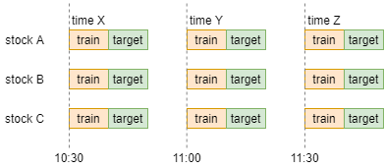

**Volatility forecasting using statistical methods**

Use Conditional correlation between stocks from precision matrix to use in MVARCH.

split it into three regimes with 2 quarters (half year) for each regime.

63*9*2 = 1134 time ids each regime.

1134, 2268, 3831

Time_id_index : 0 : 1134

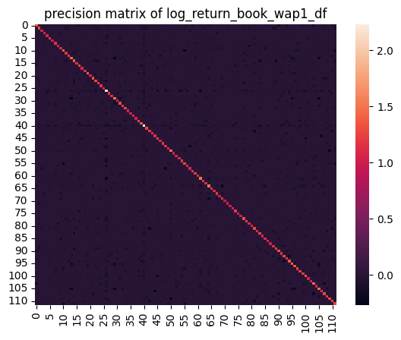

Cluster 1: [2, 64], Number of stocks: 2

Cluster 2: [6], Number of stocks: 1

Cluster 3: [3, 9, 23, 28, 29, 38, 42, 44, 50, 53, 55, 56, 60, 61, 62, 63, 69, 73, 75, 76, 78, 85, 87, 88, 90, 96, 97, 110, 112, 113, 115, 116, 118, 120, 124], Number of stocks: 35

Cluster 4: [40], Number of stocks: 1

Cluster 5: [0, 1, 4, 5, 7, 8, 10, 11, 13, 14, 15, 16, 17, 18, 19, 20, 21, 22, 26, 27, 30, 31, 32, 33, 34, 35, 36, 37, 39, 41, 43, 46, 47, 48, 51, 52, 59, 66, 67, 68, 70, 72, 74, 83, 84, 89, 93, 94, 95, 98, 100, 101, 102, 103, 104, 105, 107, 108, 109, 111, 114, 119, 122, 123, 125, 126], Number of stocks: 66

Cluster 6: [58], Number of stocks: 1

Cluster 7: [77], Number of stocks: 1

Cluster 8: [80], Number of stocks: 1

Cluster 9: [81], Number of stocks: 1

Cluster 10: [82], Number of stocks: 1

Cluster 11: [86], Number of stocks: 1

Cluster 12: [99], Number of stocks: 1

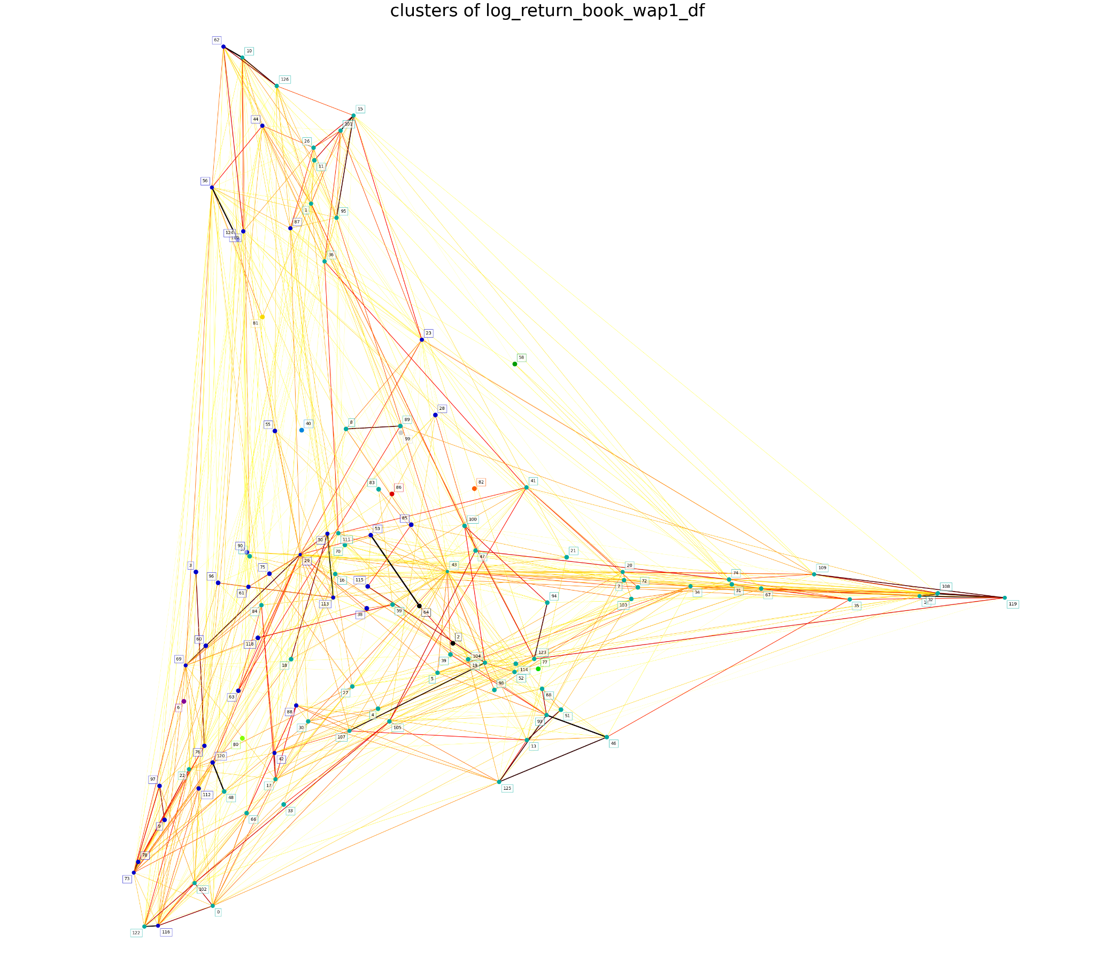

Time_id_index : 1134 : 2268

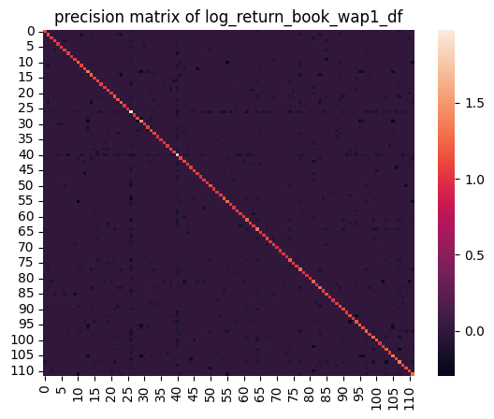

Cluster 1: [8, 89], Number of stocks: 2

Cluster 2: [10, 44, 62, 126], Number of stocks: 4

Cluster 3: [13, 51, 74, 85], Number of stocks: 4

Cluster 4: [0, 3, 5, 18, 22, 28, 29, 33, 36, 48, 50, 55, 56, 60, 61, 63, 69, 73, 75, 76, 77, 78, 81, 84, 86, 87, 90, 96, 98, 102, 110, 111, 112, 113, 116, 120, 122, 124], Number of stocks: 38

Cluster 5: [14, 31, 32, 34, 35, 100, 108, 109, 119], Number of stocks: 9

Cluster 6: [4, 7, 11, 16, 17, 19, 20, 27, 30, 37, 41, 42, 43, 47, 52, 66, 67, 70, 72, 88, 94, 103, 104, 105, 107, 114, 123], Number of stocks: 27

Cluster 7: [38, 59, 99], Number of stocks: 3

Cluster 8: [53, 64], Number of stocks: 2

Cluster 9: [80], Number of stocks: 1

Cluster 10: [82], Number of stocks: 1

Cluster 11: [2, 21, 39, 46, 68, 93, 115, 125], Number of stocks: 8

Cluster 12: [1, 15, 23, 26, 95, 101], Number of stocks: 6

Cluster 13: [6, 9, 97], Number of stocks: 3

Cluster 14: [40, 58, 83, 118], Number of stocks: 4

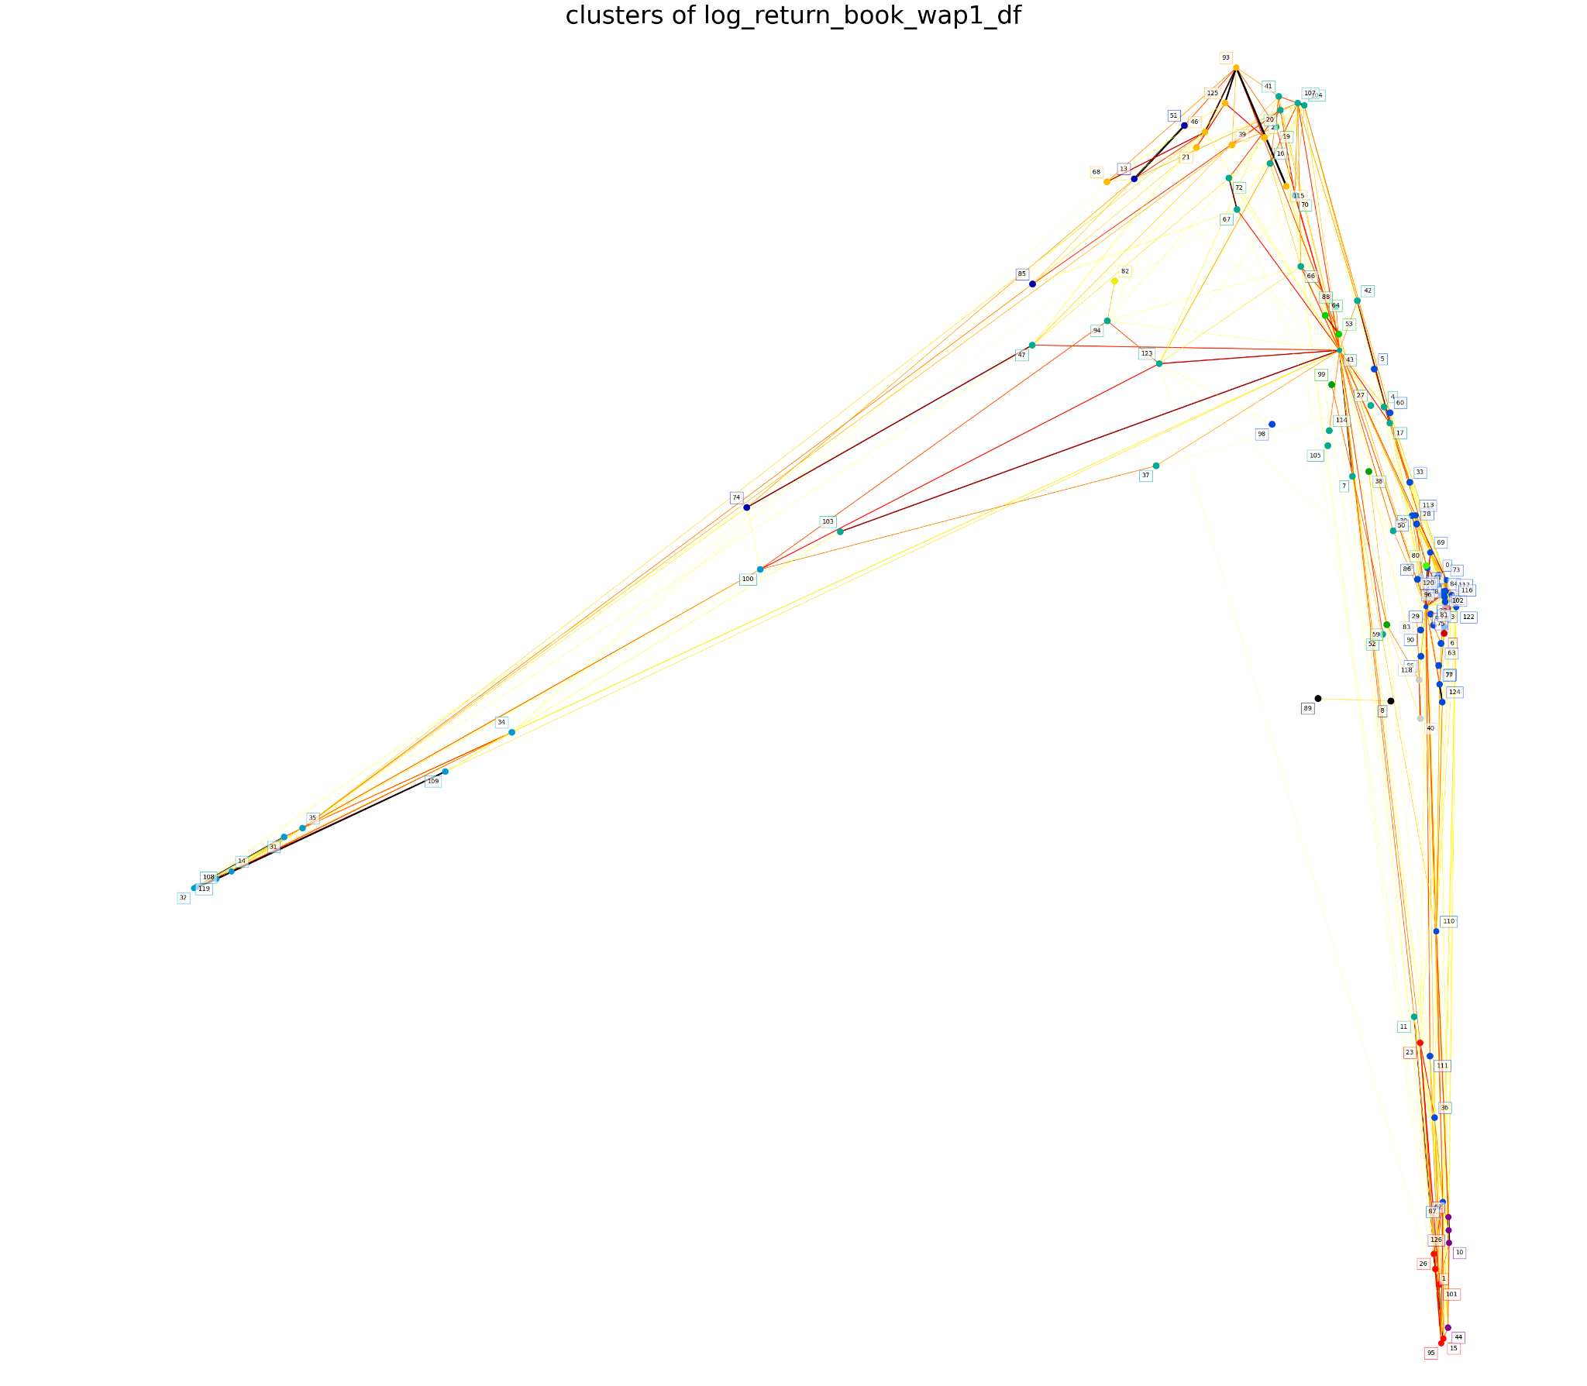

Time_id_index : 2268 : 3831

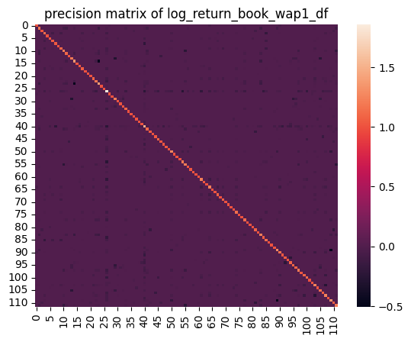

Cluster 1: [4], Number of stocks: 1

Cluster 2: [8], Number of stocks: 1

Cluster 3: [1, 11, 15, 26, 95], Number of stocks: 5

Cluster 4: [0, 3, 6, 9, 18, 22, 23, 28, 29, 33, 36, 48, 50, 55, 56, 61, 63, 69, 73, 75, 76, 77, 78, 81, 84, 86, 87, 96, 97, 102, 110, 111, 112, 113, 116, 120, 122], Number of stocks: 37

Cluster 5: [14, 31, 32, 34, 35, 108, 109, 119], Number of stocks: 8

Cluster 6: [39, 114], Number of stocks: 2

Cluster 7: [5, 7, 16, 17, 19, 20, 27, 30, 37, 41, 43, 47, 52, 60, 66, 67, 70, 72, 88, 90, 94, 100, 103, 105, 123], Number of stocks: 25

Cluster 8: [13, 51], Number of stocks: 2

Cluster 9: [58], Number of stocks: 1

Cluster 10: [38, 59, 99], Number of stocks: 3

Cluster 11: [10, 44, 62, 126], Number of stocks: 4

Cluster 12: [53, 64], Number of stocks: 2

Cluster 13: [74], Number of stocks: 1

Cluster 14: [80], Number of stocks: 1

Cluster 15: [82], Number of stocks: 1

Cluster 16: [85], Number of stocks: 1

Cluster 17: [89], Number of stocks: 1

Cluster 18: [2, 21, 46, 68, 93, 115, 125], Number of stocks: 7

Cluster 19: [98], Number of stocks: 1

Cluster 20: [101, 124], Number of stocks: 2

Cluster 21: [42, 104, 107], Number of stocks: 3

Cluster 22: [40, 83, 118], Number of stocks: 3

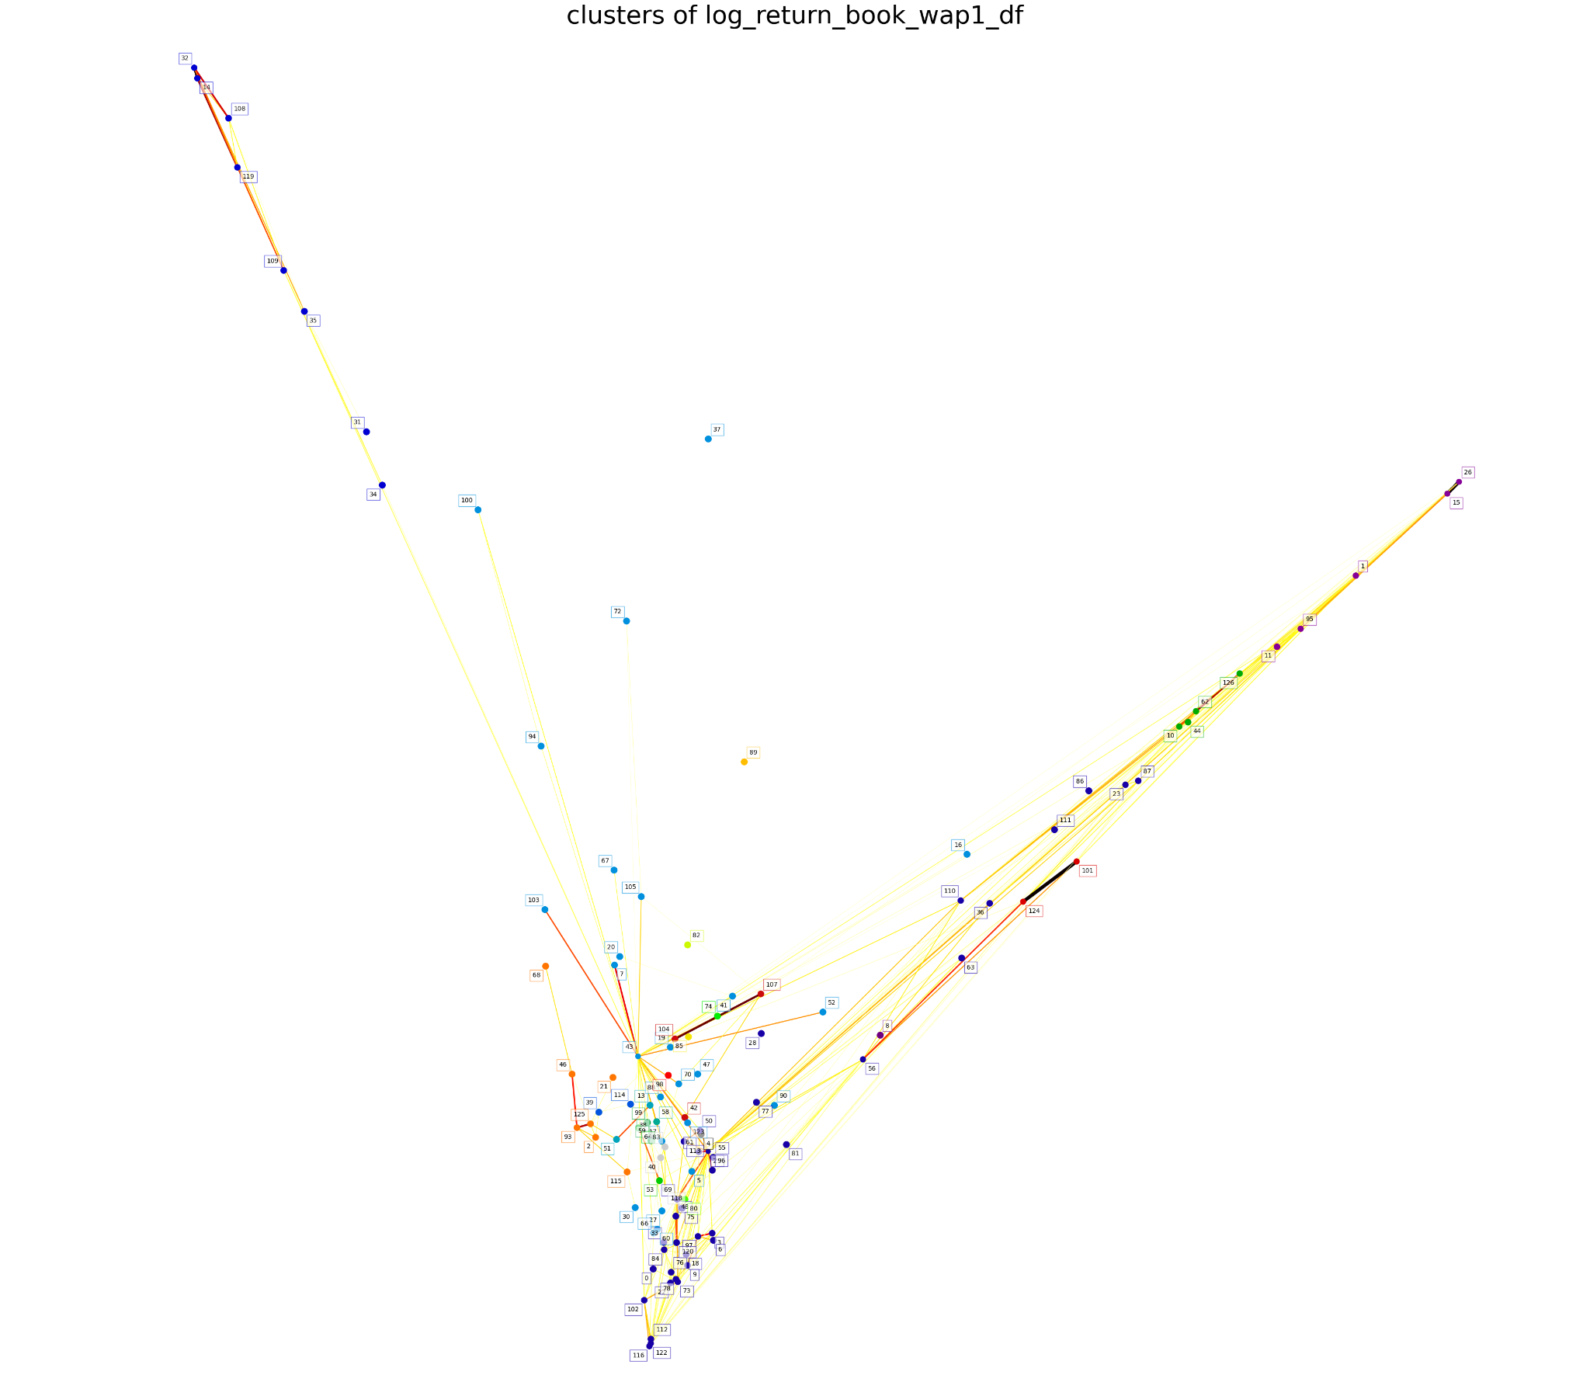

Time_id_index : 0 : 1134

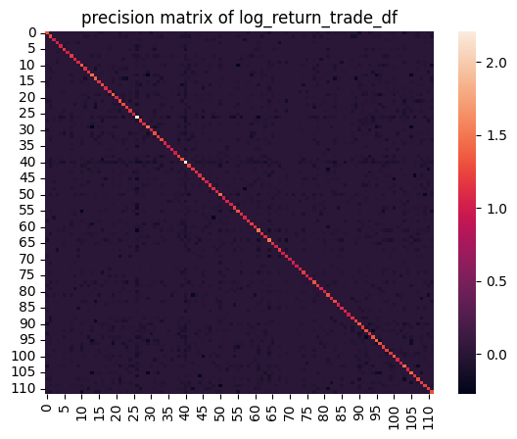

Cluster 1: [6], Number of stocks: 1

Cluster 2: [3, 4, 9, 22, 23, 28, 29, 36, 37, 38, 42, 44, 50, 55, 56, 60, 61, 62, 63, 69, 73, 75, 76, 78, 85, 87, 88, 89, 90, 96, 97, 110, 112, 113, 115, 116, 118, 120, 124], Number of stocks: 39

Cluster 3: [40], Number of stocks: 1

Cluster 4: [0, 1, 5, 7, 8, 10, 11, 13, 14, 15, 16, 17, 18, 19, 20, 21, 26, 27, 30, 31, 32, 33, 34, 35, 39, 41, 43, 46, 47, 48, 51, 52, 59, 66, 67, 68, 70, 72, 74, 83, 84, 93, 94, 95, 98, 100, 101, 102, 103, 104, 105, 107, 108, 109, 111, 114, 119, 122, 123, 125, 126], Number of stocks: 61

Cluster 5: [58], Number of stocks: 1

Cluster 6: [2, 53, 64], Number of stocks: 3

Cluster 7: [77], Number of stocks: 1

Cluster 8: [80], Number of stocks: 1

Cluster 9: [81], Number of stocks: 1

Cluster 10: [82], Number of stocks: 1

Cluster 11: [86], Number of stocks: 1

Cluster 12: [99], Number of stocks: 1

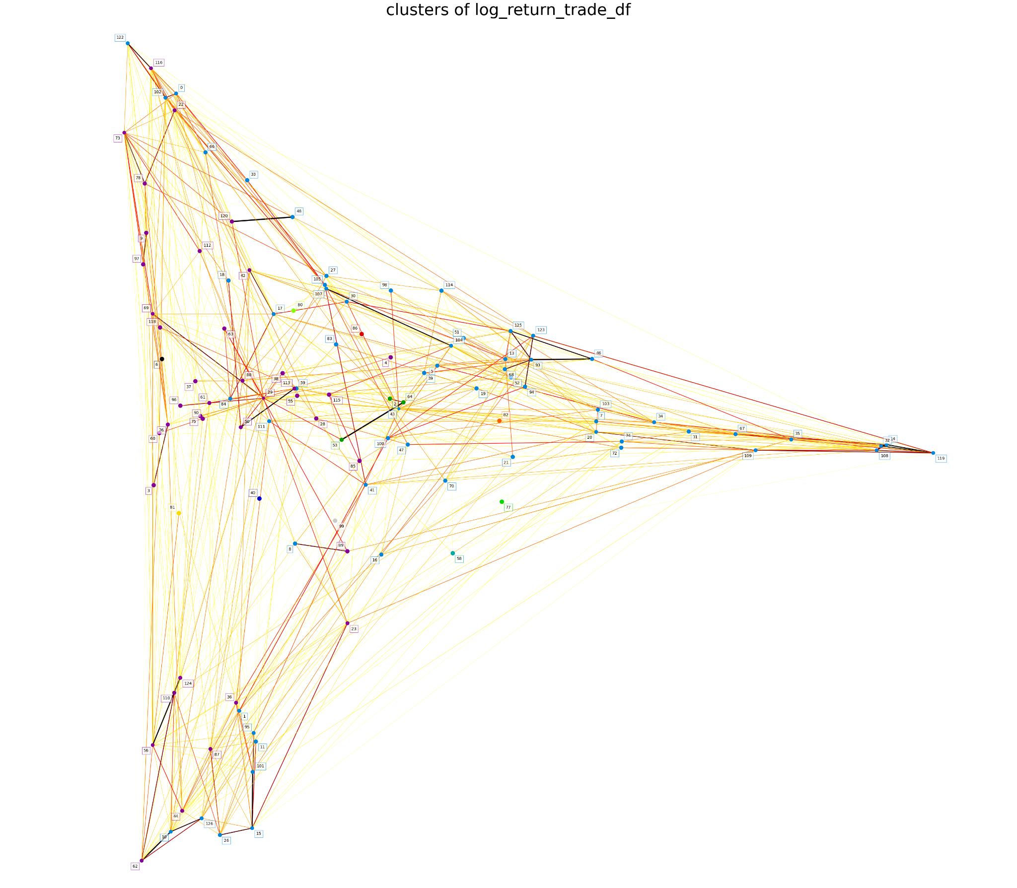

Time_id_index : 1134 : 2268

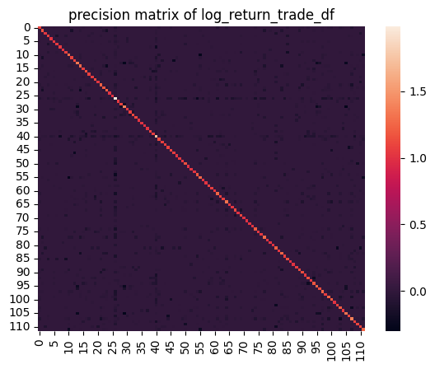

Cluster 1: [8, 89], Number of stocks: 2

Cluster 2: [10, 62, 126], Number of stocks: 3

Cluster 3: [13, 51, 74, 85], Number of stocks: 4

Cluster 4: [1, 15, 26, 44, 95, 101], Number of stocks: 6

Cluster 5: [0, 5, 18, 22, 28, 29, 33, 36, 48, 50, 55, 56, 60, 61, 63, 69, 73, 75, 76, 77, 78, 81, 84, 86, 87, 90, 96, 98, 102, 110, 111, 112, 113, 116, 120, 122, 124], Number of stocks: 37

Cluster 6: [14, 31, 32, 34, 35, 100, 108, 109, 119], Number of stocks: 9

Cluster 7: [4, 7, 11, 16, 17, 19, 20, 23, 27, 30, 37, 38, 41, 42, 43, 47, 52, 66, 67, 70, 72, 88, 94, 103, 104, 105, 107, 114, 123], Number of stocks: 29

Cluster 8: [58], Number of stocks: 1

Cluster 9: [53, 64], Number of stocks: 2

Cluster 10: [80], Number of stocks: 1

Cluster 11: [82], Number of stocks: 1

Cluster 12: [2, 21, 39, 46, 68, 93, 115, 125], Number of stocks: 8

Cluster 13: [3, 6, 9, 97], Number of stocks: 4

Cluster 14: [59, 99], Number of stocks: 2

Cluster 15: [40, 83, 118], Number of stocks: 3

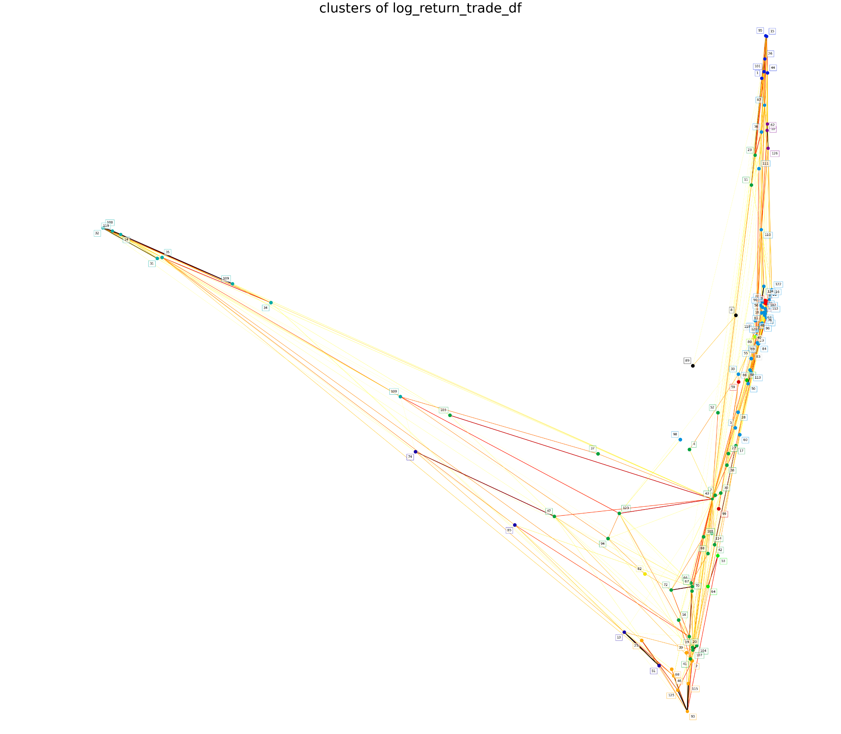

Time_id_index : 2268 : 3831

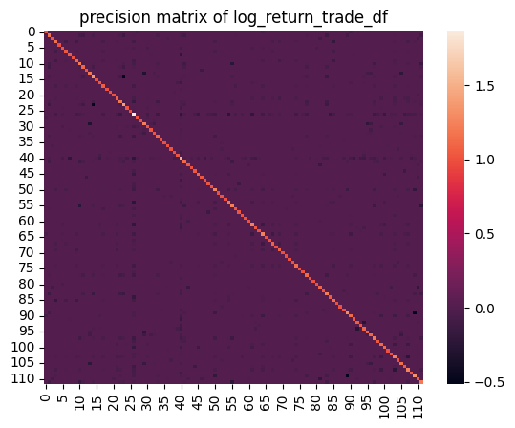

Cluster 1: [4], Number of stocks: 1

Cluster 2: [8], Number of stocks: 1

Cluster 3: [1, 11, 15, 26, 95], Number of stocks: 5

Cluster 4: [0, 3, 6, 9, 18, 22, 23, 28, 29, 33, 36, 48, 50, 55, 56, 61, 63, 66, 69, 73, 75, 76, 78, 81, 84, 86, 87, 96, 97, 102, 110, 111, 112, 113, 116, 120, 122], Number of stocks: 37

Cluster 5: [14, 31, 32, 34, 35, 108, 109, 119], Number of stocks: 8

Cluster 6: [5, 7, 16, 17, 19, 20, 27, 30, 37, 41, 43, 47, 52, 60, 67, 70, 72, 88, 90, 94, 100, 103, 105, 114, 123], Number of stocks: 25

Cluster 7: [13, 51], Number of stocks: 2

Cluster 8: [58], Number of stocks: 1

Cluster 9: [38, 59, 99], Number of stocks: 3

Cluster 10: [10, 44, 62, 126], Number of stocks: 4

Cluster 11: [53, 64], Number of stocks: 2

Cluster 12: [74], Number of stocks: 1

Cluster 13: [77], Number of stocks: 1

Cluster 14: [80], Number of stocks: 1

Cluster 15: [82], Number of stocks: 1

Cluster 16: [85], Number of stocks: 1

Cluster 17: [89], Number of stocks: 1

Cluster 18: [2, 21, 39, 46, 68, 93, 115, 125], Number of stocks: 8

Cluster 19: [98], Number of stocks: 1

Cluster 20: [101, 124], Number of stocks: 2

Cluster 21: [42, 104, 107], Number of stocks: 3

Cluster 22: [40, 83, 118], Number of stocks: 3

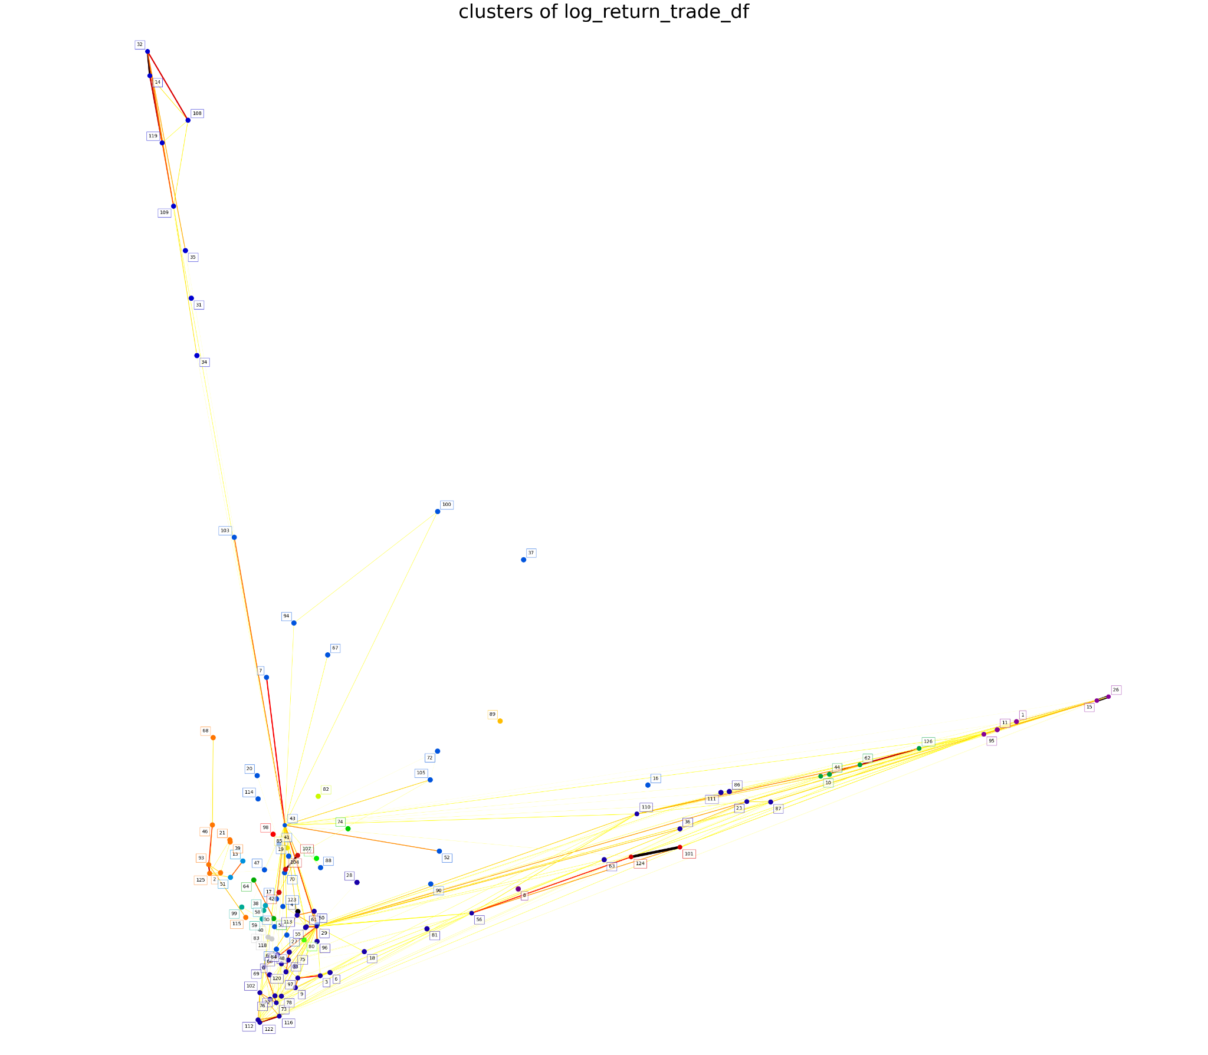

What are the mathematical equations of the models AR(3), HAR, HARQ, HARQ-F, CHAR, HARS, HARQ-J given in <https://github.com/jacob-hein/HAR-models-forecasting-realized-volatility-in-US-stocks/tree/main>

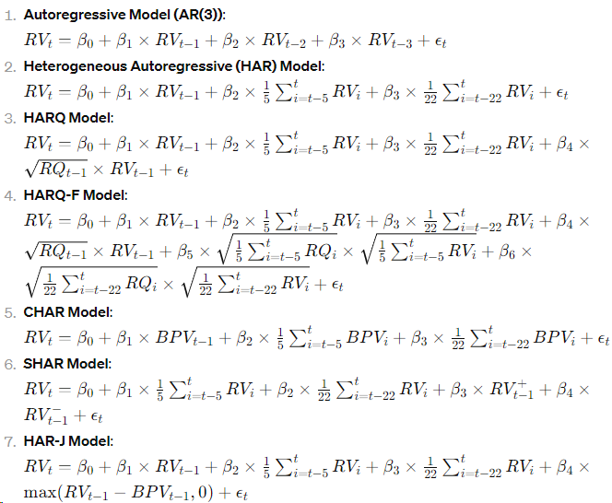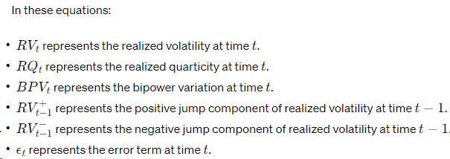

**Results from the HAR model**

**Book wap1**

RANK which model gives least errors.

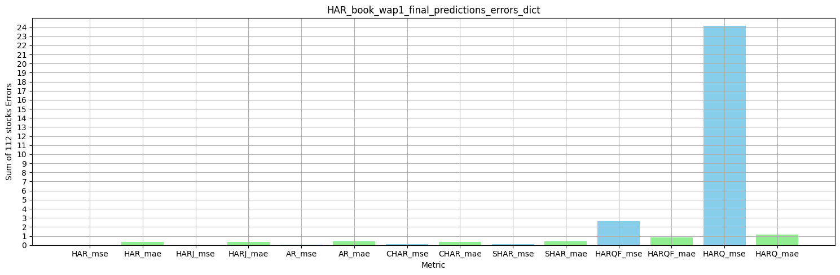

zOOMED VERSIONs

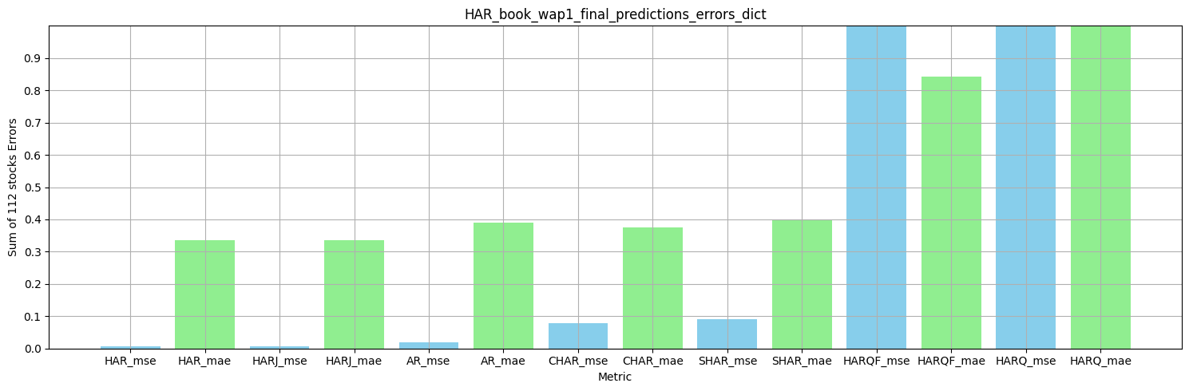

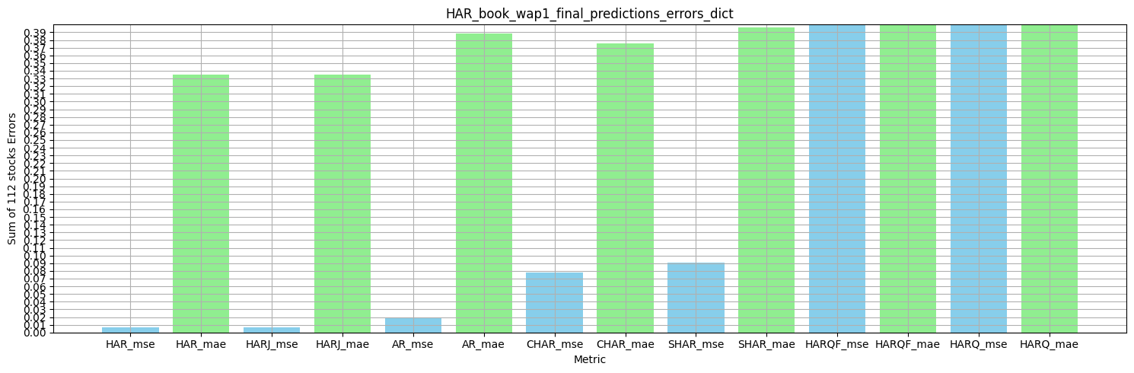

HAR or HARJ are the best models for book wap1

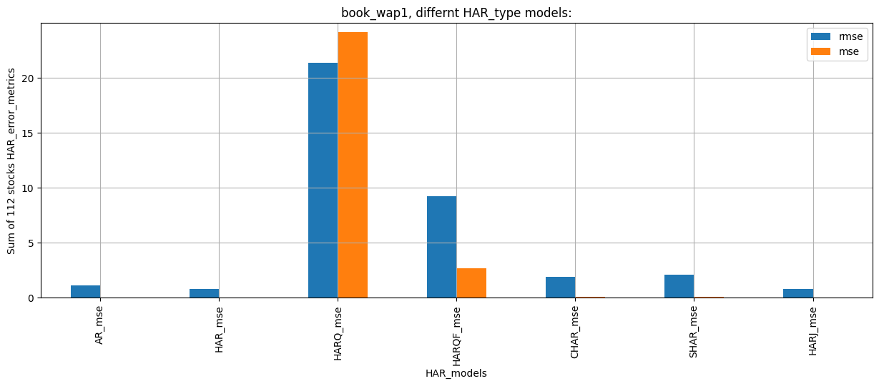

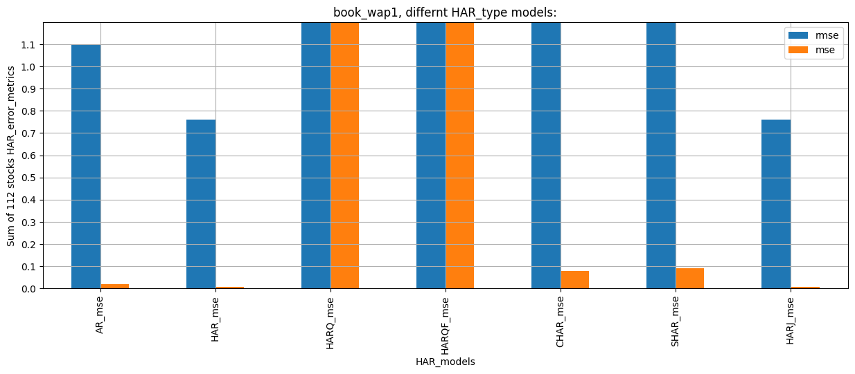

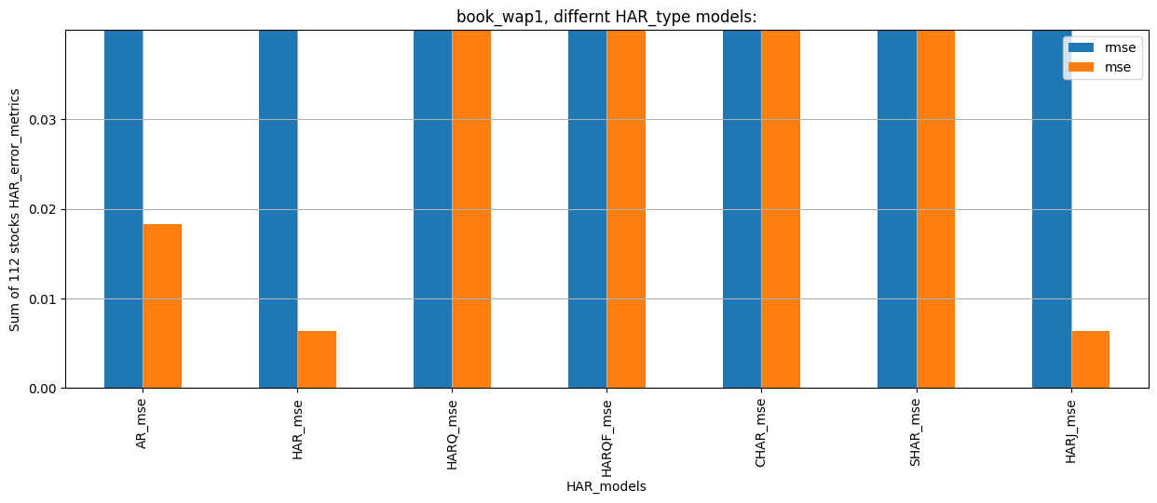

HAR, HARJ and AR are good models.

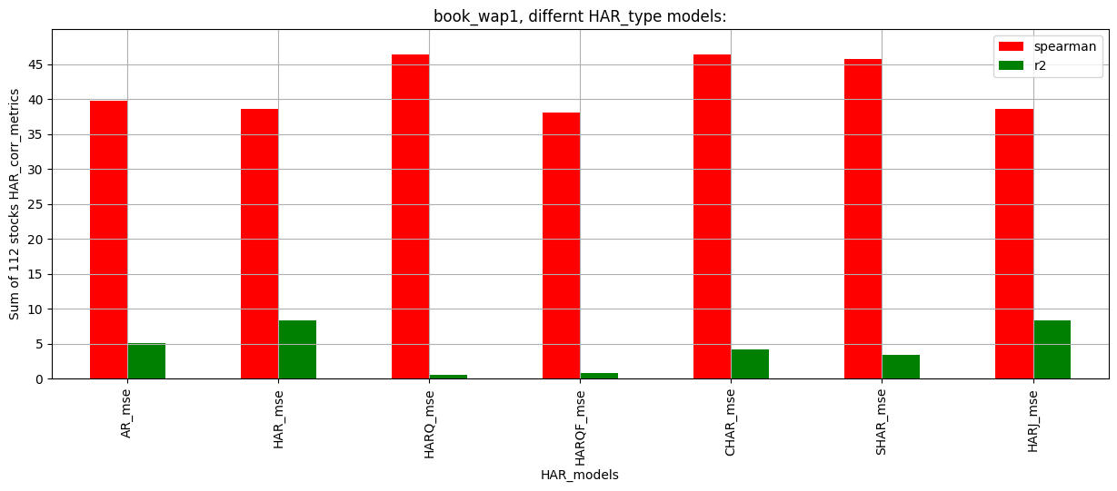

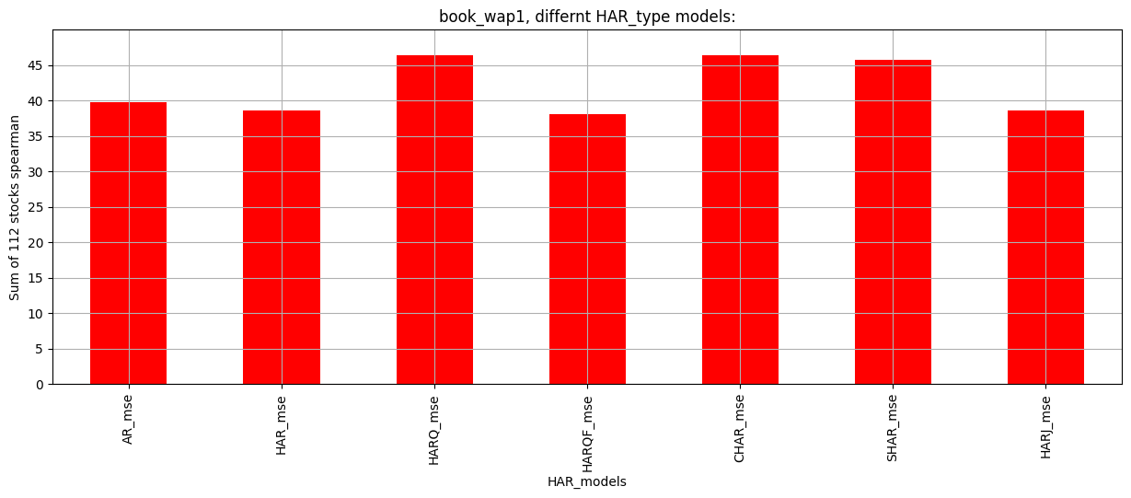

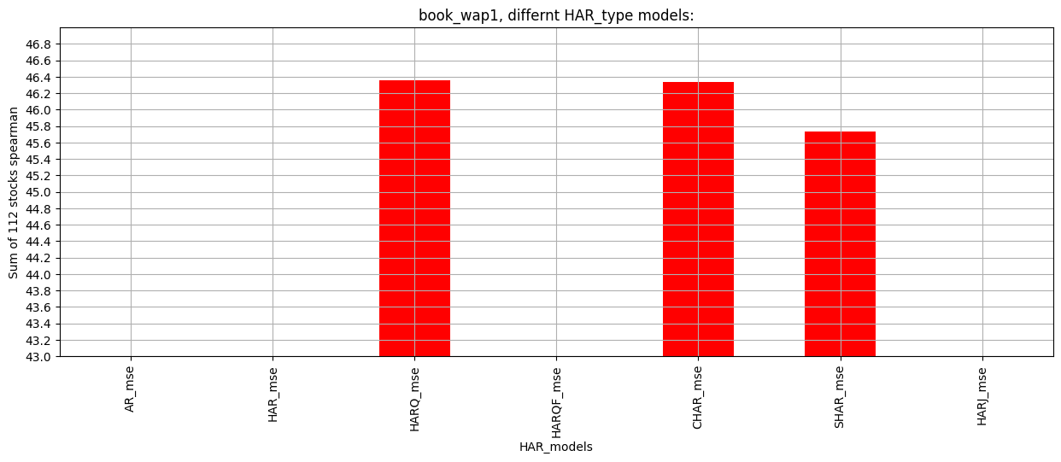

HARQ and CHAR have highest spearman.

AR, then HAR then HARJ.

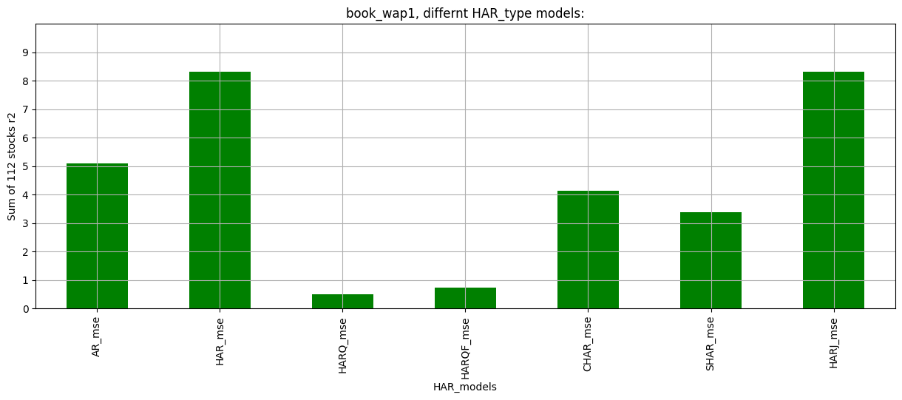

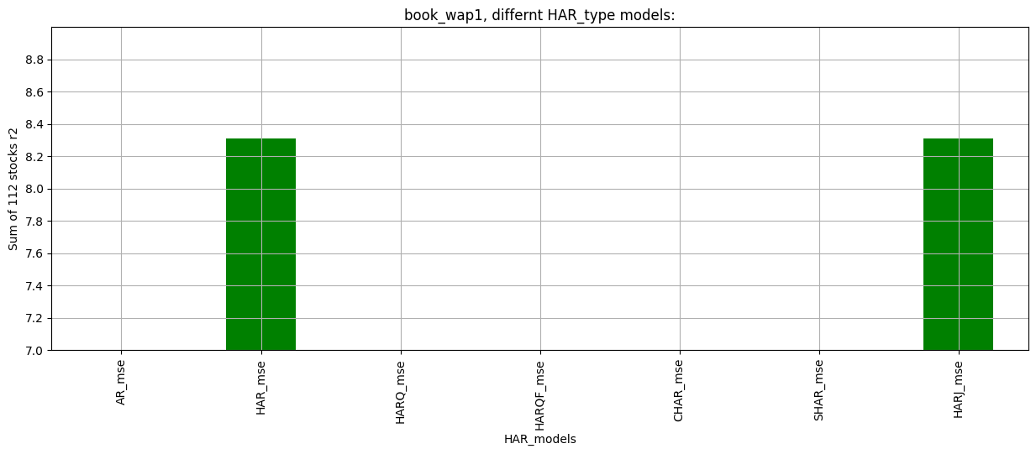

HAR and HARJ are good models

**Trade price**

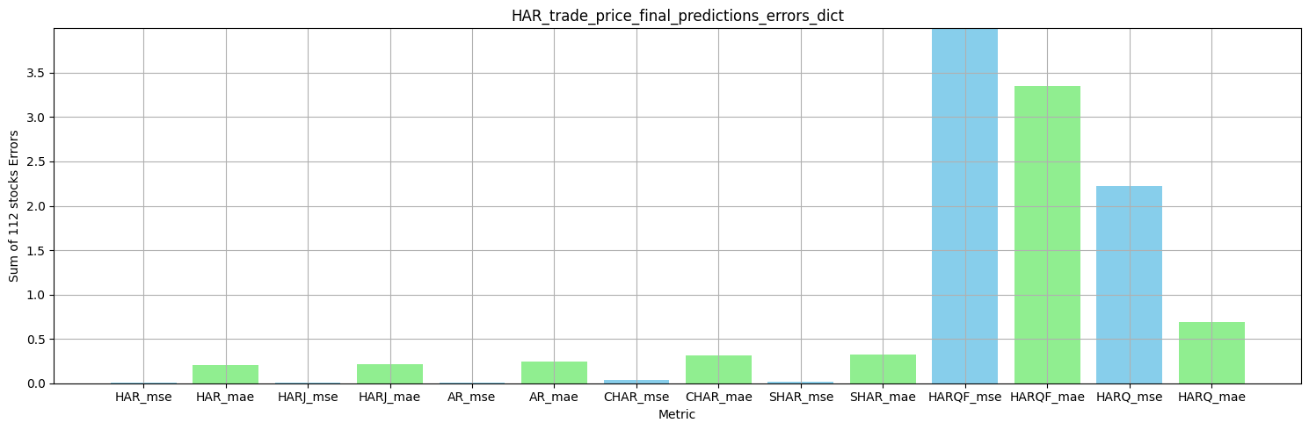

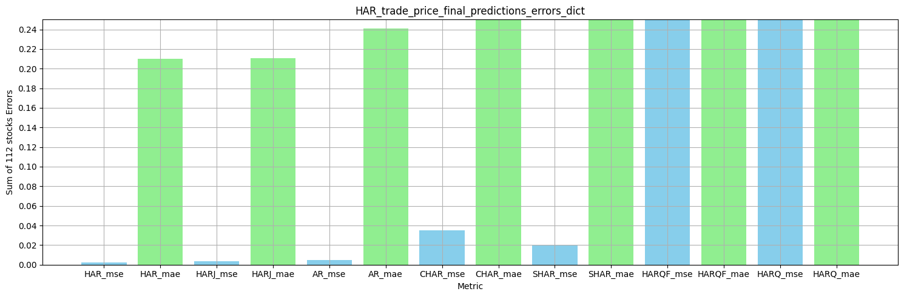

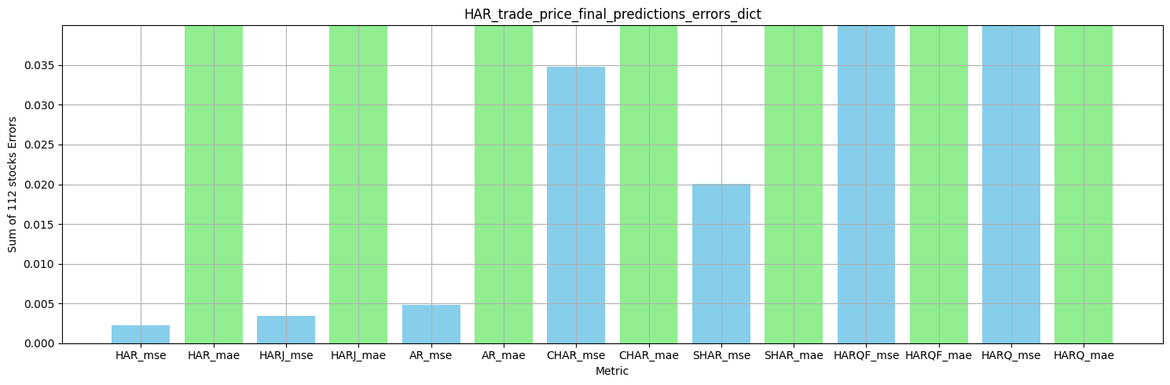

HAR or HARJ are the best models for trade price.

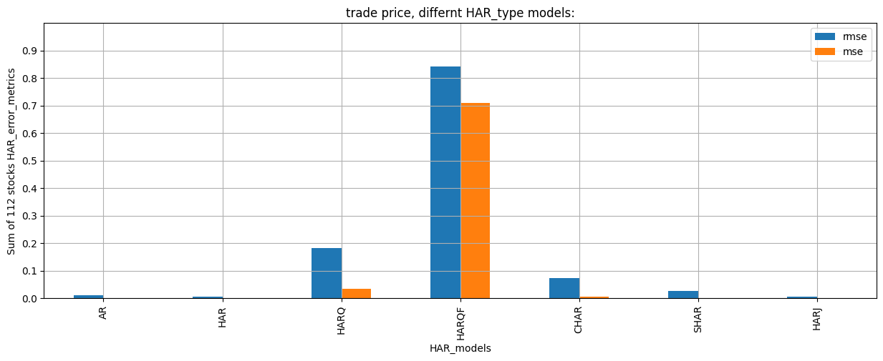

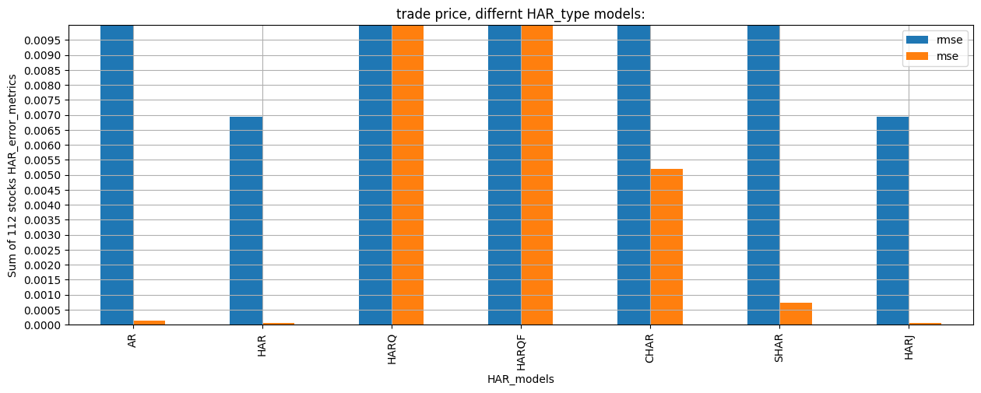

HAR and HARJ are the best.

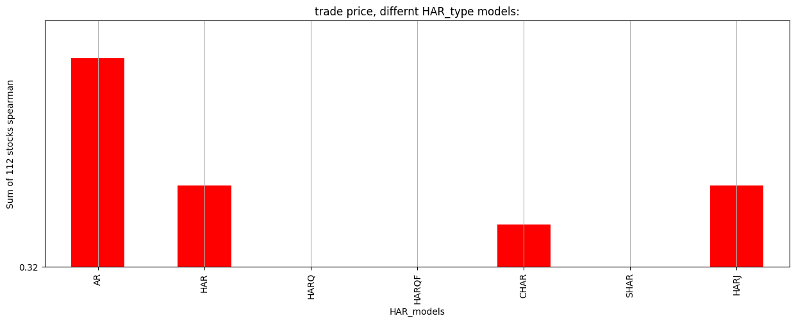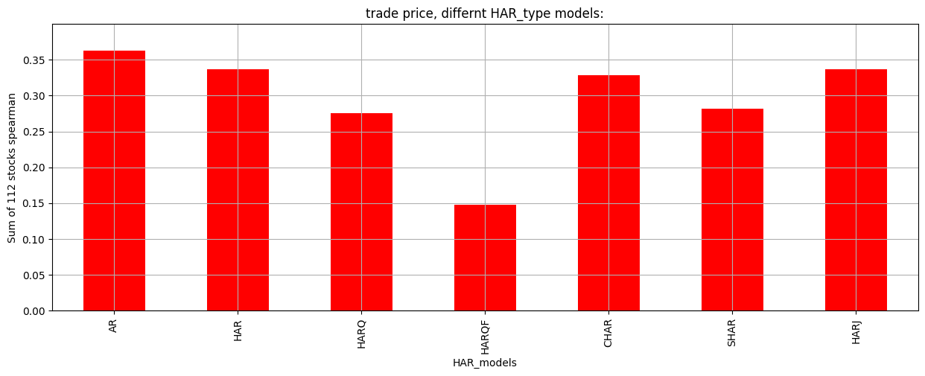

AR, HAR, HARJ are the best

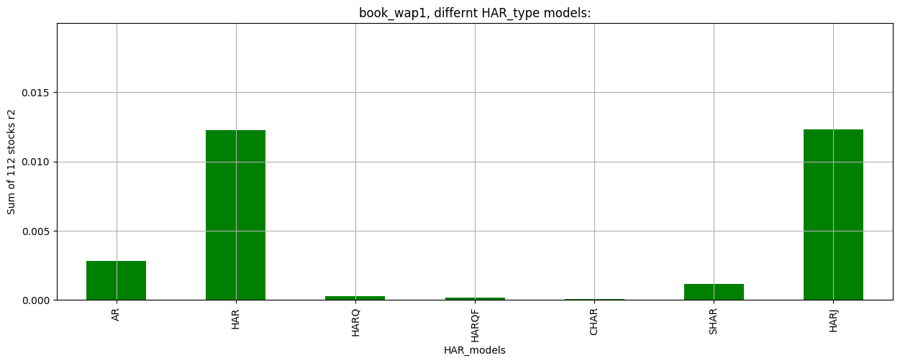

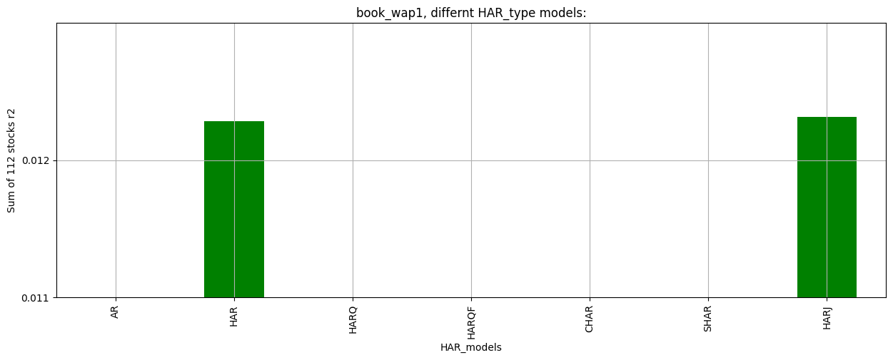

HAR and HARJ are the best

***CONCLUSION:***

Use HAR, HARJ and AR outputs in that order for both book wap1 volatilities and trade price volatilities.

Also use extra features RQ, RV, BPV, RSV+,RSV- both book wap1 volatilities and trade price volatilities.